Dominoes overview

Domino-X Earth Observation Project

Exported on 2023-11-17 16:09:16

Table of Contents

1 Domino-X Ground Segment Overview 6

1.1 Domino's perimeter 6

1.2 Domino's optionality 7

1.3 Focus on the central role of the [Federation Service] 7

2 Functional Architecture 8

3 Functional exchanges 9

4 Reading guide 10

4.1 Introduction of the domino framework 10

4.2 Legend of diagrams 10

5 (ACS) Archive/Catalogue Service to be updated 11

5.1 Overall description 11

5.2 Main functions 11

5.3 Interfaces 11

6 (ADGS) Auxiliary Data Gathering Service 12

6.1 Overall description 12

6.2 Main functions 12

6.3 Interfaces 12

7 (APS) Advanced Processing Service 13

7.1 Overall description 13

7.2 Main functions 13

7.3 Interfaces 13

8 (CS) TM/TC Ciphering Service 14

8.1 Overall description 14

8.2 Main functions 14

8.3 Interfaces 14

9 (DDS) Data Distribution Service 15

9.1 Overall description 15

9.2 Main functions 15

9.3 Interfaces 15

10 (DITS) Data Integrity and Traceability Service 16

10.1 Overall description 16

10.2 Main functions 16

10.3 Interfaces 16

11 (EPS) Enhanced Processing Service 17

11.1 Overall description 17

11.2 Main functions 17

11.3 Interfaces 17

12 (FDS) Flight Dynamics Service 18

12.1 Overall description 18

12.2 Main functions 18

12.3 Interfaces 18

13 (FOS) Flight Operation Service 19

13.1 Overall description 19

13.2 Main functions 19

13.3 Interfaces 19

14 (FS) Federation Service 20

14.1 Overall description 20

14.2 Main functions 20

14.3 Interfaces 20

15 (INTS) Interoperability Service 21

15.1 Overall description 21

15.2 Main functions 21

15.3 Interfaces 21

16 (IQS) Image Quality Service 22

16.1 Overall description 22

16.2 Main functions 22

16.3 Interfaces 22

17 (KBDS) Knowledge Builder and Decision Service 23

17.1 Overall description 23

17.2 Main functions 24

17.3 Detailled functions 24

17.4 Interfaces 25

18 (MAPQS) Machine-learning Application Production & Quality Service 26

18.1 Overall description 26

18.2 Main functions 26

18.3 Interfaces 26

19 (MPS) Mission Programming Service 28

19.1 Overall description 28

19.2 Main functions 28

19.3 Interfaces 28

20 (OMS) Operational Monitoring Service 29

20.1 Overall description 29

20.2 Main functions 29

20.3 Interfaces 29

21 (PPS) Primary Processing Service 31

21.1 Overall description 31

21.2 Main functions 31

21.3 Interfaces 31

22 (SCMS) System Configuration Mgmt Service 32

22.1 Overall description 32

22.2 Main functions 32

22.3 Interfaces 32

23 (SCRMS) Satellite Communication and Resources Management Service 33

23.1 Overall description 33

23.2 Main functions 33

23.3 Interfaces 34

24 (SMS) Security Monitoring Service 35

24.1 Overall description 35

24.2 Main functions 35

24.3 Interfaces 35

25 (SSS) Satellite Simulator Service 36

25.1 Overall description 36

25.2 Main functions 36

25.3 Interfaces 36

26 (UAS) User Access Service 37

26.1 Overall description 37

26.2 Main functions 37

26.3 Interfaces 37

Domino-X ground segment offers the following main services :

* Multi-Mission User Services
* Missions Services
* Satellite Command & Control Services (SCC)
* Resources Mgmt Services
* Processing Services
* Data Management Services
* Reactivity Services
* Monitoring Services

Each main service can be implemented by one or more dominoes (see Domino-X BreakDown Structure below)

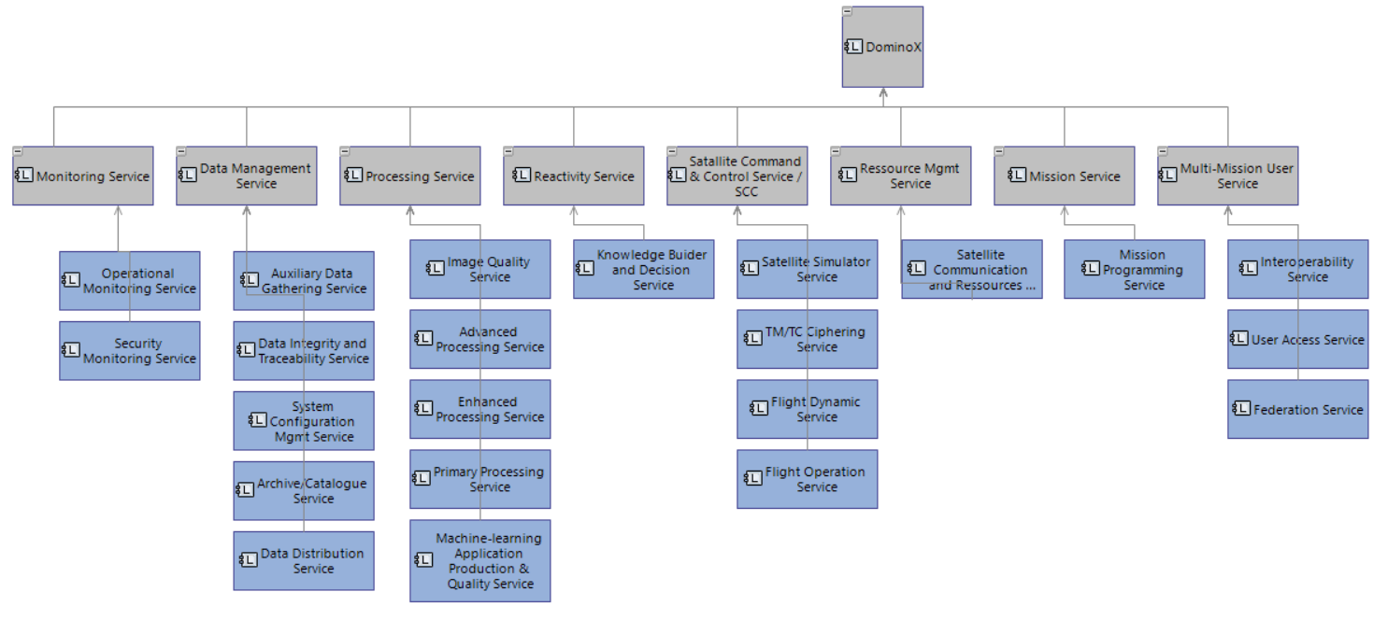

*Diagram extracted from the capella model*

A domino provides a valuable service useful to any earth observation ground Segment. It

* Autonomously produces outputs from a set of inputs
* May serve several missions
* Can be deployed on a cloud
* Is independent from other dominoes infrastructure
* Is accountable for its performances
* Is interchangeable by another implementation respecting the same interfaces

*Note : A domino is not a toolbox or a framework and not a building block (not a library).*

A domino can be :

* Dedicated to one mission (homogeneous constellation of satellites) or to several missions (multi-missions)
* Deployed on customer premises (on a dedicated hardware) or on a public or private cloud
* Deployed as a service (aas) provided by an industrial or as a delivered component
* Deployed in a unique way (central), by design or many concurrent implementation can be deployed
* Integrates mandatory or optional features

Inter-domino data and service exchanges are realized through communication standards such as OGS API or Open API 3.0 and standard formats such as JSON.

The Domino-X ground segment is interfaced to :

* External service providers through dedicated interoperability services
* External data providers/consumers
* Owned ground stations or can call ground station cloud services (GSaas)

Domino-X ground segment can be operated with very few operators and provides products to numerous End-Users.

# Domino-X Ground Segment Overview

The diagram below illustrates all the concepts presented above.

[Domino-X Ground Segment.pptx](https://wiki-external.thalesaleniaspace.fr/download/attachments/276989165/Domino-X%20Ground%20Segment.pptx?api=v2&modificationDate=1676989935000&version=1)

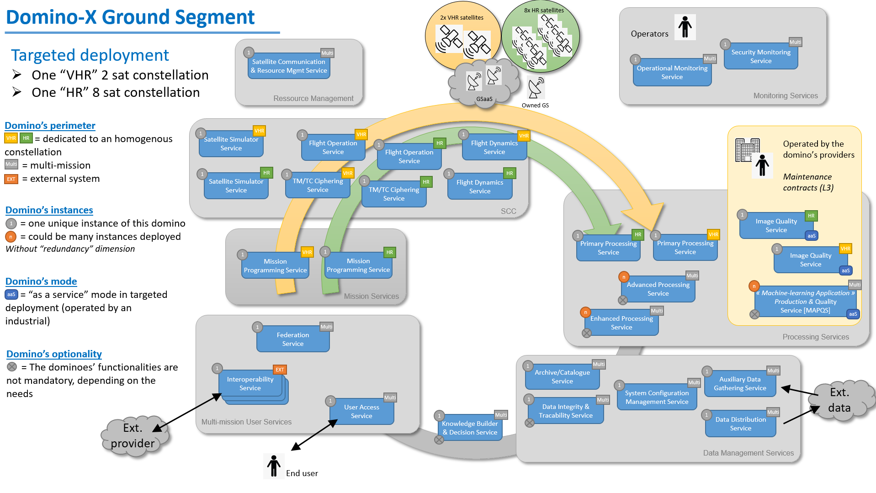

## Domino's perimeter

A domino could be multi-missions, or dedicated to one mission. In the diagram above :

* Green color label  is dedicated to HR (High Resolution) satellites    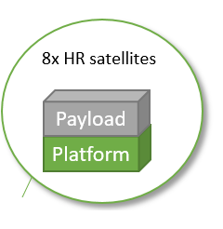
* Yellow color label  is dedicated to VHR (Very High Resolution) satellites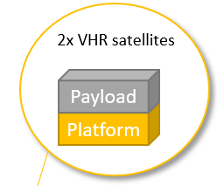
* Payload-dependent dominoes :
  + Mission Programming Service       : [MPS] domino is linked with the mission capabilities and particularities, and knows the details of the payload control
  + Primary Processing Service            : [PPS] domino knows the instrument particularities and knows how to decipher and decompress the ITM. It also knows how to build a “perfect sensor” product, without these particularities
  + Satellite Simulator Service             : [SSS] domino simulates the behaviour of the spacecraft platform (and the payload control)
* Platform-dependant dominoes :
  + Mission Programming Service   :  [MPS] domino knows the platform characteristics, and computes the satellite’s manoeuver between acquisitions.
  + TM/TC Ciphering Service           :  [CS] domino is linked with the on-board ciphering/deciphering equipment and its capabilities.
  + Flight Operation Service            :  [FOS] domino is linked with the spacecraft platform characteristics.
  + Flight Dynamics Service             :  [FDS] is linked with the spacecraft platform characteristics.
  + Satellite Simulator Service         :  [SSS] domino simulates the behaviour of the spacecraft platform (and the payload control).

## Domino's optionality

A domino can integrate mandatory features or optional features :

* Advanced Processing Service :  In case [APS] domino is missing, the Ground Segment will not be able to process image with processing level greater than pivot level (perfect sensor), without other major impact.
* Enhanced Processing Service (and its Quality Service) : In case [EPS] domino is missing, the Ground Segment will not be able to use image extraction algorithms, without other major impact.
* Knowledge Builder & Decision Service : In case [KBDS] domino is missing, the Ground Segment will loose its ability to follow-up an event (detect/react/synthetize) and to enhance the image product (metadata), without other major impact.
* Data Integrity and Traceability Service : In case [DITS] domino is missing, the Ground Segment will not be able to check the products integrity, and to provide their traceability.

## Focus on the central role of the [Federation Service]

The Federation Service [FS] is a major component of the Domino-X Ground Segment. [FS] proposes :

* User requests management
* Services on the discovery of other dominoes
* Organization of production workflows
* Local and external systems optimization

# Functional Architecture

Refer to Logical Architecture Diagram (LAB) done on CAPELLA.

Note: The functional exchanges (direction of the arrows) go from the producer to the consumer of the data.

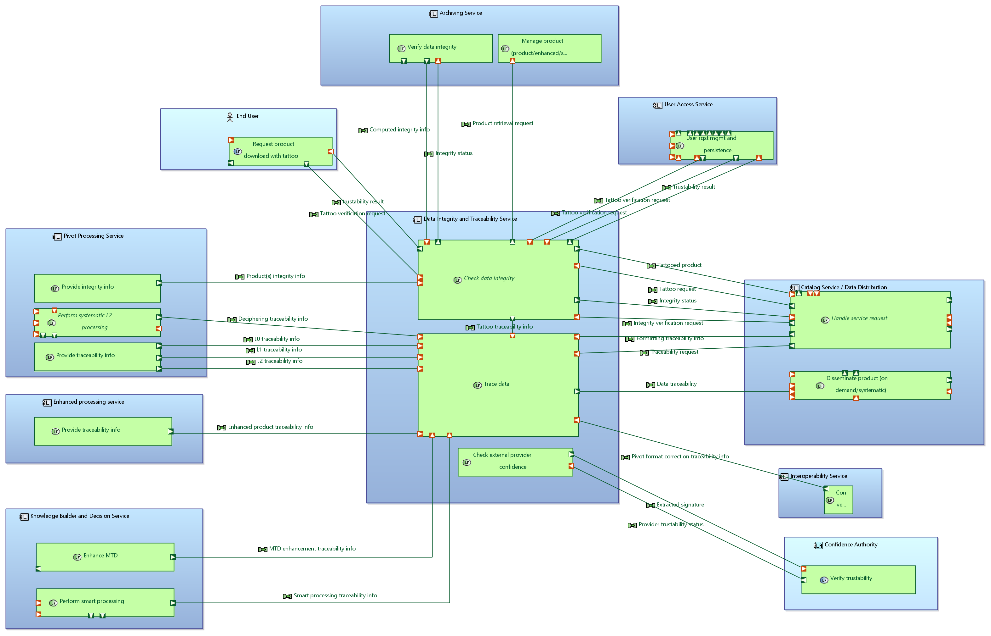

(Schema dated November 2022)

# Functional exchanges

Refer to Exchange Scenarios (ES) done on CAPELLA.

Note : The functional exchanges (direction of the arrows) go from the emitter of the data/information to its receiver.

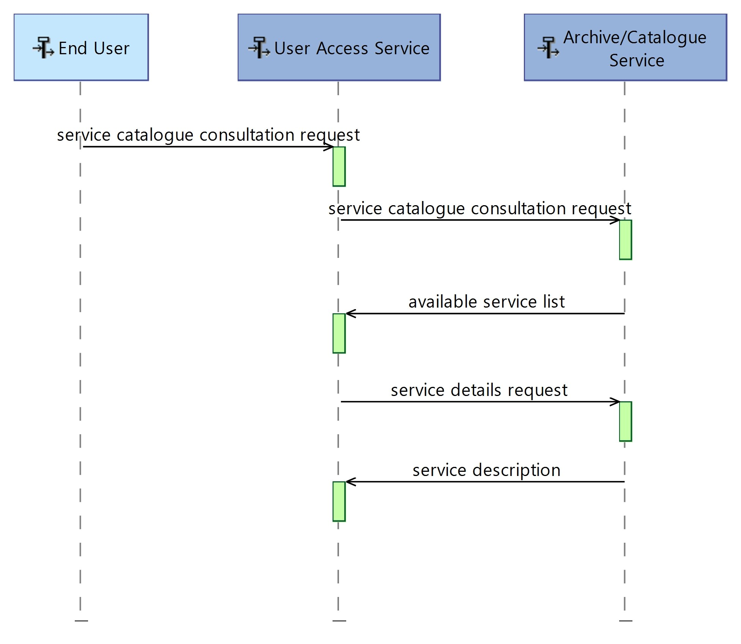

# Reading guide

## Introduction of the domino framework

All dominoes must provide a certain number of common functions (related to operational maintenance) and propose the interfaces related to them.

In order not to overload the modeling and documentation these functions are hosted by a virtual domino called **Framework domino**.

## Legend of diagrams

[LegendOfDiagrams.pptx](https://wiki-external.thalesaleniaspace.fr/download/attachments/281248070/LegendOfDiagrams.pptx?api=v2&modificationDate=1675875327000&version=1)

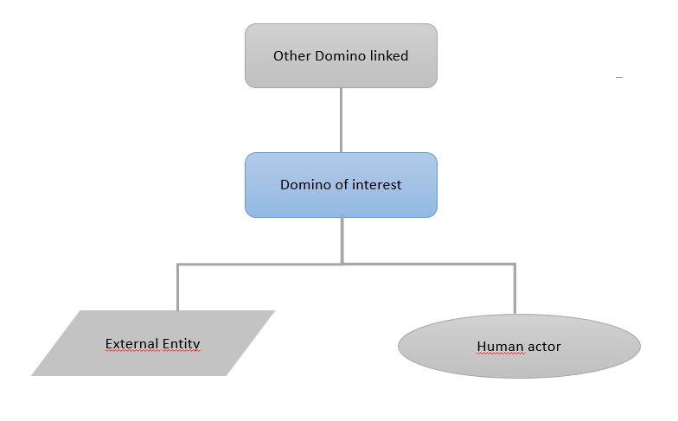

# (ACS) Archive/Catalogue Service to be updated

## Overall description

The Archive/Catalogue Service (ACS) domino is responsible to ease products  access offering archive, indexation/cataloguing  and search capabilities.

## Main functions

* Search Data with formated or Natural Language request
* Check Products Access Rights
* Process Natural Language
* Catalog product including metadata modification
* Archive products including integrity verification

## Interfaces

Level-2-IA-Quality-Operator to be deleted

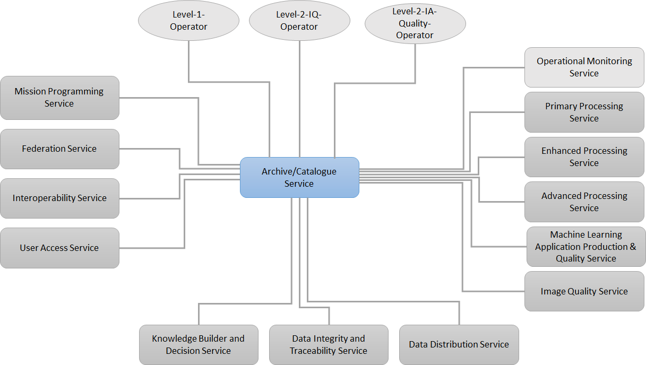

[ACS.pptx](https://wiki-external.thalesaleniaspace.fr/download/attachments/296323546/ACS.pptx?api=v2&modificationDate=1693294900000&version=13)

(info) See the "ICD Master" for the interfaces details

# (ADGS) Auxiliary Data Gathering Service

## Overall description

The Auxiliary Data Gathering Service (ADGS) domino handles the gathering of all auxiliary data entering the Ground Segment. As such, it is in interface with all dominoes needing such data.

## Main functions

* Retrieve auxiliary data from external providers
* Select the best data (validity period, update)
* Provide external data to the dominoes

## Interfaces

[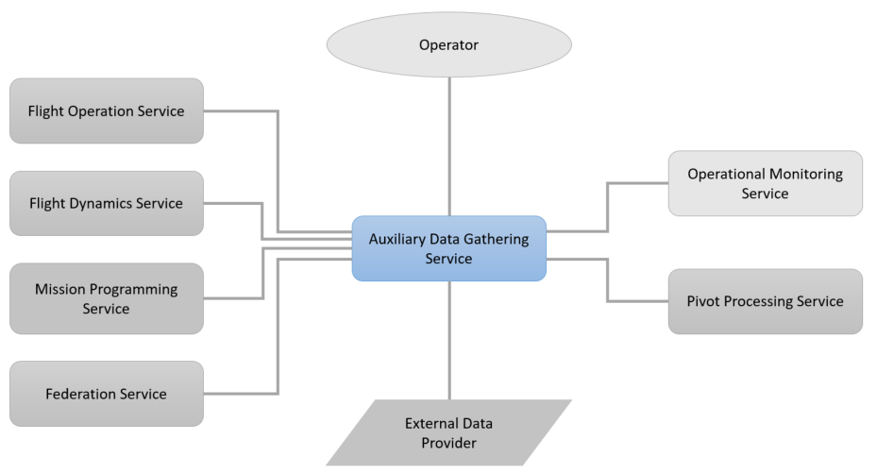](https://wiki-external.thalesaleniaspace.fr/download/attachments/296323697/ADGS.pptx?api=v2&modificationDate=1680186407000&version=5)

[ADGS.pptx](https://wiki-external.thalesaleniaspace.fr/download/attachments/296323697/ADGS.pptx?api=v2&modificationDate=1680186407000&version=5)

(info) See the "ICD Master" for the interfaces details

# (APS) Advanced Processing Service

## Overall description

The Avanced Processing Service (APS) domino is responsible for the production of image product of higher levels than Pivot.

## Main functions

* Perform on-demand processing to higher product level according to processing capabilities exposed on APS service catalogue (typically within the L3 to L7 frame)

## Interfaces

[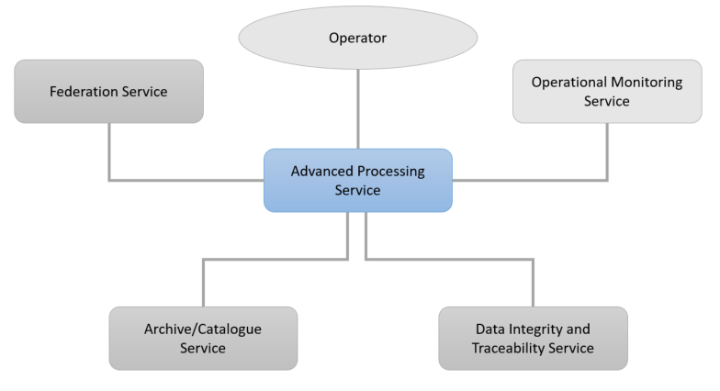](https://wiki-external.thalesaleniaspace.fr/download/attachments/296323460/APS.pptx?api=v2&modificationDate=1680183680000&version=2)

[APS.pptx](https://wiki-external.thalesaleniaspace.fr/download/attachments/296323460/APS.pptx?api=v2&modificationDate=1680183680000&version=2)

(info) See the "ICD Master" for the interfaces details

# (CS) TM/TC Ciphering Service

## Overall description

The TM/TC Ciphering Service (CS) domino is responsible for securing S-band communications.

## Main functions

* Manage S-Band keys :
  + Generate
  + Deploy
  + Supervise life-cycle
* Cipher TC
* Decipher TM

*NB: The TMI deciphering and the key management are included into the “Pivot Processing Service” domino.*

## Interfaces

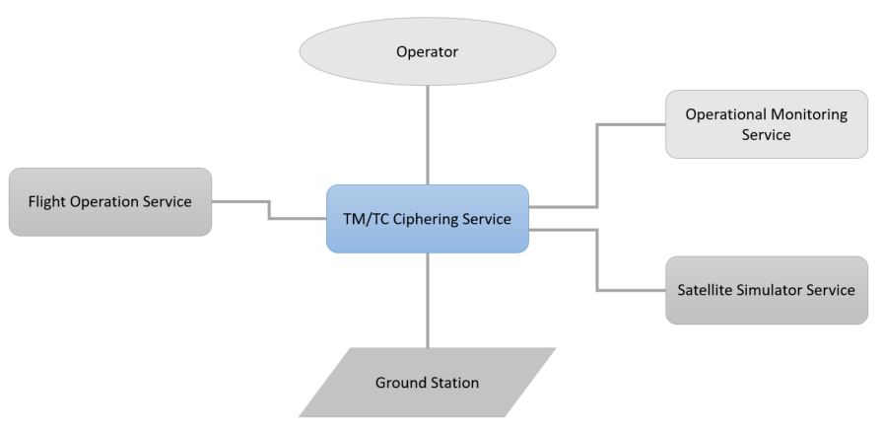

[CS.pptx](https://wiki-external.thalesaleniaspace.fr/download/attachments/296323746/CS.pptx?api=v2&modificationDate=1680186228000&version=3)

(info) See the "ICD Master" for the interfaces details

# (DDS) Data Distribution Service

## Overall description

The Data Distribution Service (DDS) domino is responsible to disseminate request products (on demand/systematic).

## Main functions

* Disseminate requested products (on demand/systematic)
* Provide traceability information
* Handle formatting request

## Interfaces

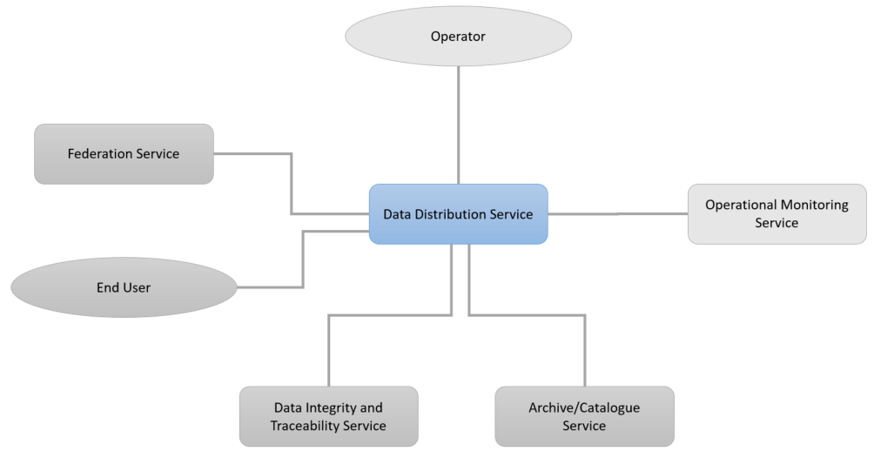

[DDS.pptx](https://wiki-external.thalesaleniaspace.fr/download/attachments/296323789/DDS.pptx?api=v2&modificationDate=1680187029000&version=5)

(info) See the "ICD Master" for the interfaces details

# (DITS) Data Integrity and Traceability Service

## Overall description

The Data Integrity and Traceability Service (DITS) domino is responsible for ensuring confidence in data handled by the system and end-users.

## Main functions

* Systematic or on-demand signature of the data produced
* On-demand data/provider integrity verification
* Data traceability throughout its life in the system

## Interfaces

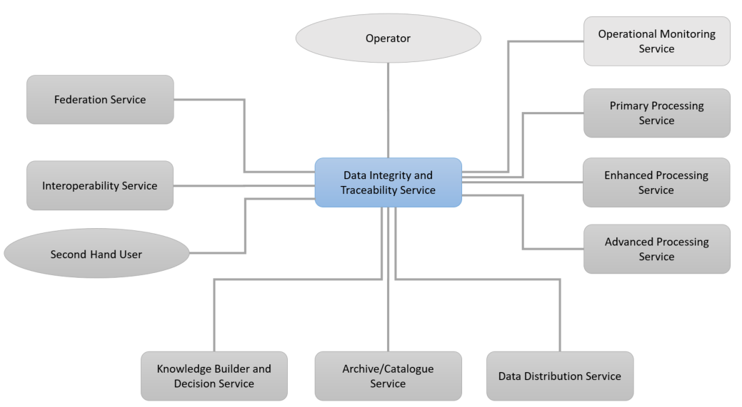

[DITS.pptx](https://wiki-external.thalesaleniaspace.fr/download/attachments/296323815/DITS.pptx?api=v2&modificationDate=1680187731000&version=4)

(info) See the "ICD Master" for the interfaces details

# (EPS) Enhanced Processing Service

## Overall description

The Enhanced Processing Service (EPS) domino is responsible for extracting information from the products generated by the PPS (ie object detection, change detection...).

## Main functions

* Perform on-demand enhanced processing to generate enhanced products according to processing capabilities exposed on EPS service catalogue.

## Interfaces

[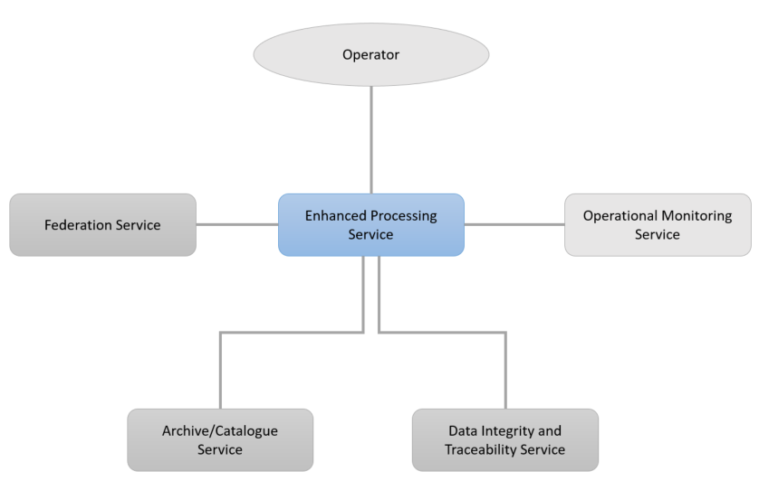](https://wiki-external.thalesaleniaspace.fr/download/attachments/296323915/EPS.pptx?api=v2&modificationDate=1680188035000&version=5)

[EPS.pptx](https://wiki-external.thalesaleniaspace.fr/download/attachments/296323915/EPS.pptx?api=v2&modificationDate=1680188035000&version=5)

(info) See the "ICD Master" for the interfaces details

# (FDS) Flight Dynamics Service

## Overall description

The Flight Dynamics Service (FDS) domino is in charge of controlling the satellite’s orbit during its whole lifetime.

## Main functions

* Determine the current orbit
* Predict the future trajectory
* Predict orbital events (eclipses…)
* Compute orbit control manoeuvres
* Compute collision avoidance manoeuvres

## Interfaces

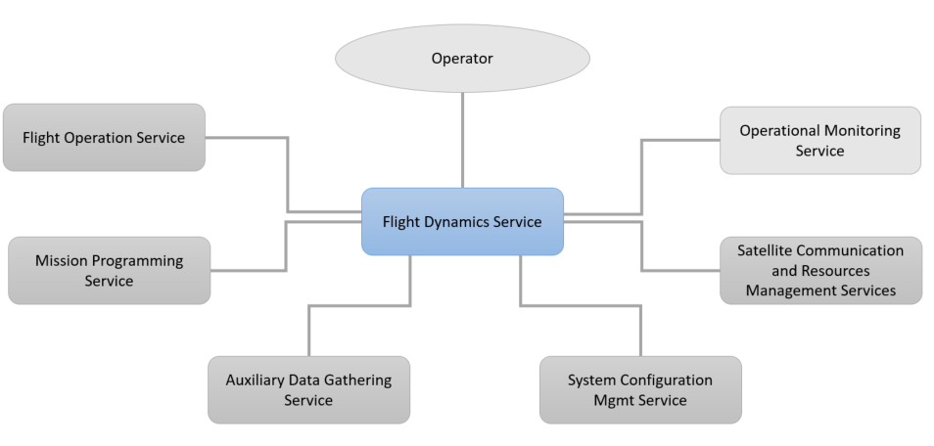

[FDS.pptx](https://wiki-external.thalesaleniaspace.fr/download/attachments/296322874/FDS.pptx?api=v2&modificationDate=1680188281000&version=4)

(info) See the "ICD Master" for the interfaces details

# (FOS) Flight Operation Service

## Overall description

The Flight Operation Service (FOS) domino monitors the satellites status by receiving and analysing telemetry and controls the satellite behaviour by sending telecommands.

## Main functions

* Schedule the activities planning
* Process and monitor housekeeping telemetry
* Export parameters
* Prepare the TC plans
* Control the satellites

## Interfaces

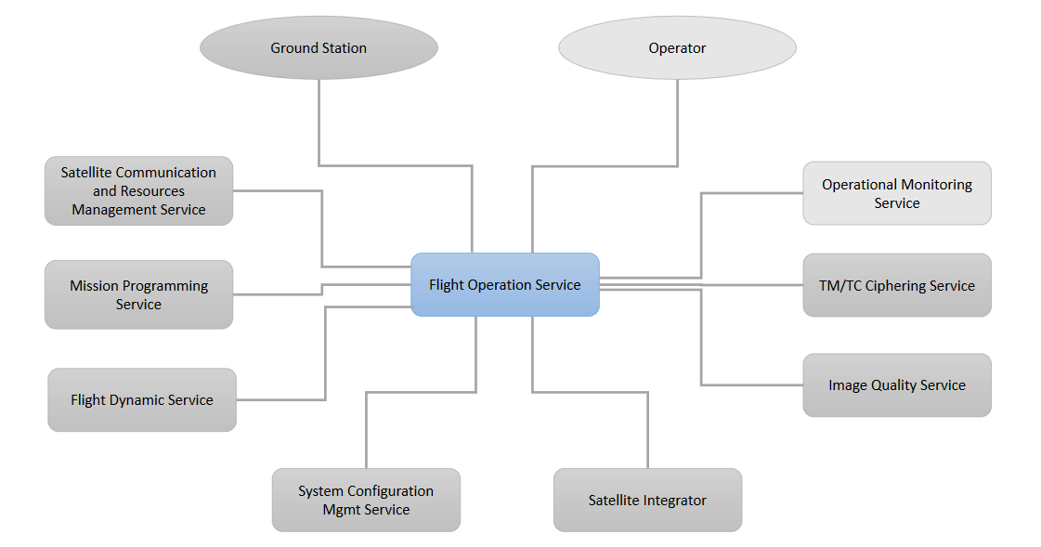

[FOS.pptx](https://wiki-external.thalesaleniaspace.fr/download/attachments/296324027/FOS.pptx?api=v2&modificationDate=1687780584000&version=5)

(info) See the "ICD Master" for the interfaces details

# (FS) Federation Service

## Overall description

The Federation Service (FS) domino is in charge of offering unified services to the UAS while optimizing the use of federated systems and performing orchestration of dominoes activities. It gathers functions for User Requests management, and sequencing of related processing activities. [FS] Domino owns the User Requests, as so it is in charge of store them and every updates related to them (updates, follow-up, cancellation).

## Main functions

* Distribution of federated systems capabilities
* User Requests management
* Programming requests feasibility analyses
* Multi-mission programming
* Management of production “inter dominoes” workflows
* Management of event follow-up requests including automatic reprogramming
* Notifications to UAS

## Interfaces

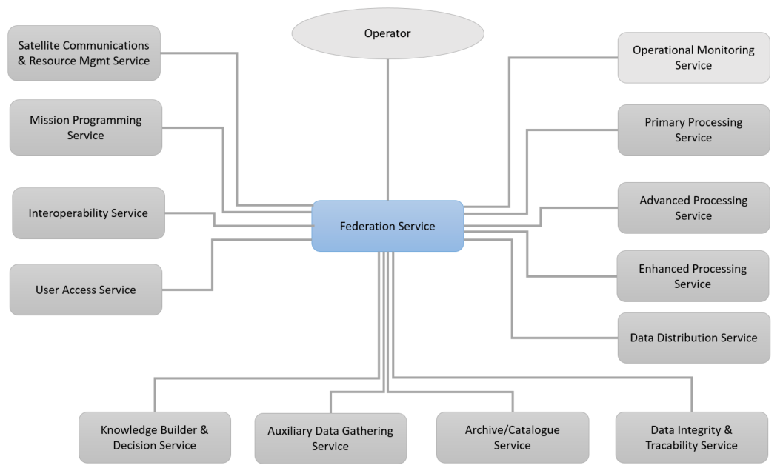

[FS.pptx](https://wiki-external.thalesaleniaspace.fr/download/attachments/296323955/FS.pptx?api=v2&modificationDate=1680189844000&version=6)

(info) See the "ICD Master" for the interfaces details

# (INTS) Interoperability Service

## Overall description

The Interoperability Service (INTS) domino gathers the functions necessary to communicate with external systems (not built on the DOMINO-X standards). It can be commercial systems, legacy systems... Interoperability takes care of the interfaces adaptation.

## Main functions

* Retrieval and distribution of external systems capabilities
* List and retrieve products from external catalogues
* Submit programming requests on external systems (and follow-up)
* Submit production requests submission (and follow-up)
* Convert downloaded products to pivot format

## Interfaces

[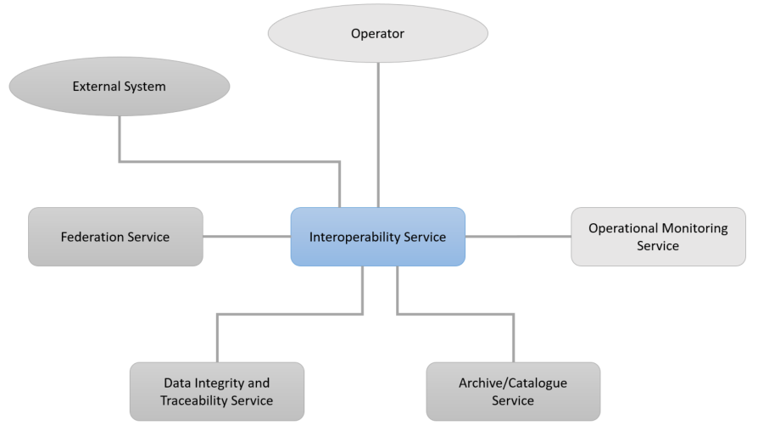](https://wiki-external.thalesaleniaspace.fr/download/attachments/296324097/INTS.pptx?api=v2&modificationDate=1680190363000&version=2)

[INTS.pptx](https://wiki-external.thalesaleniaspace.fr/download/attachments/296324097/INTS.pptx?api=v2&modificationDate=1680190363000&version=2)

(info) See the "ICD Master" for the interfaces details

# (IQS) Image Quality Service

## Overall description

The Image Quality Service (IQS) domino regroups the tools dedicated to monitoring and calibration of image quality of earth observation system.  It runs automatically a basic surveillance of radiometric and geometric quality of the products and propose expert tools for operators for more complex QI tasks.

## Main functions

* Monitor IQ value
* Compute calibration parameters
* Process image quality anomaly

## Interfaces

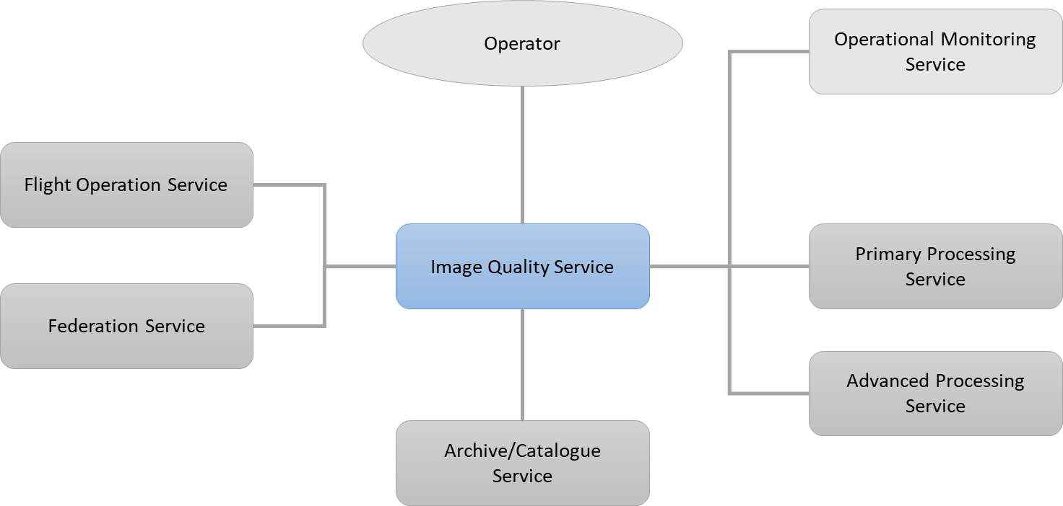

[IQS.pptx](https://wiki-external.thalesaleniaspace.fr/download/attachments/296324052/IQS.pptx?api=v2&modificationDate=1687435265000&version=5)

(info) See the "ICD Master" for the interfaces details

# (KBDS) Knowledge Builder and Decision Service

## Overall description

The Knowledge Builder and Decision Service (KBDS) domino regroups a set of knowledge builder and decision functions.

For knowledge build, the KBDS is activated by a Level-2-operator.

For decision functions, the KBDS is activated by an UserRequest of type EventFollowUpRequest configured by the End User.

This EventFollowUpRequest configuration is relative to scenario:

1. For a detection from external source as web, the EventType=WebEvent and details are described in EventParameters.
2. For a detection from products (images and metadata), the EventType=Product. A SourceProductRequest is associated to this request.

In either scenario, when the event occurs through web analysis or product analysis, the KBDS raises an alert to the End-User via [UAS] and activates a ConditionProductRequest to [FS] for reprogramming purpose.

This ConditionProductRequest previsouly defined by the End User and stored by FS is triggered by KBDS.

This ProductRequest may include a combination of:

* a ProgrammingRequest held by [MPS]
* a ProductionRequest held by [PPS], [EPS] and/or [APS]
* a DeliveryRequest held by [DDS].

The following diagram shows the links between UAS, FS, KBDS, PPS, EPS, APS, DDS and DITS requests.

Especially, the [MPS] ProgrammingRequest parameters that [KBDS] may overwrite are highlighted in blue (TBC).

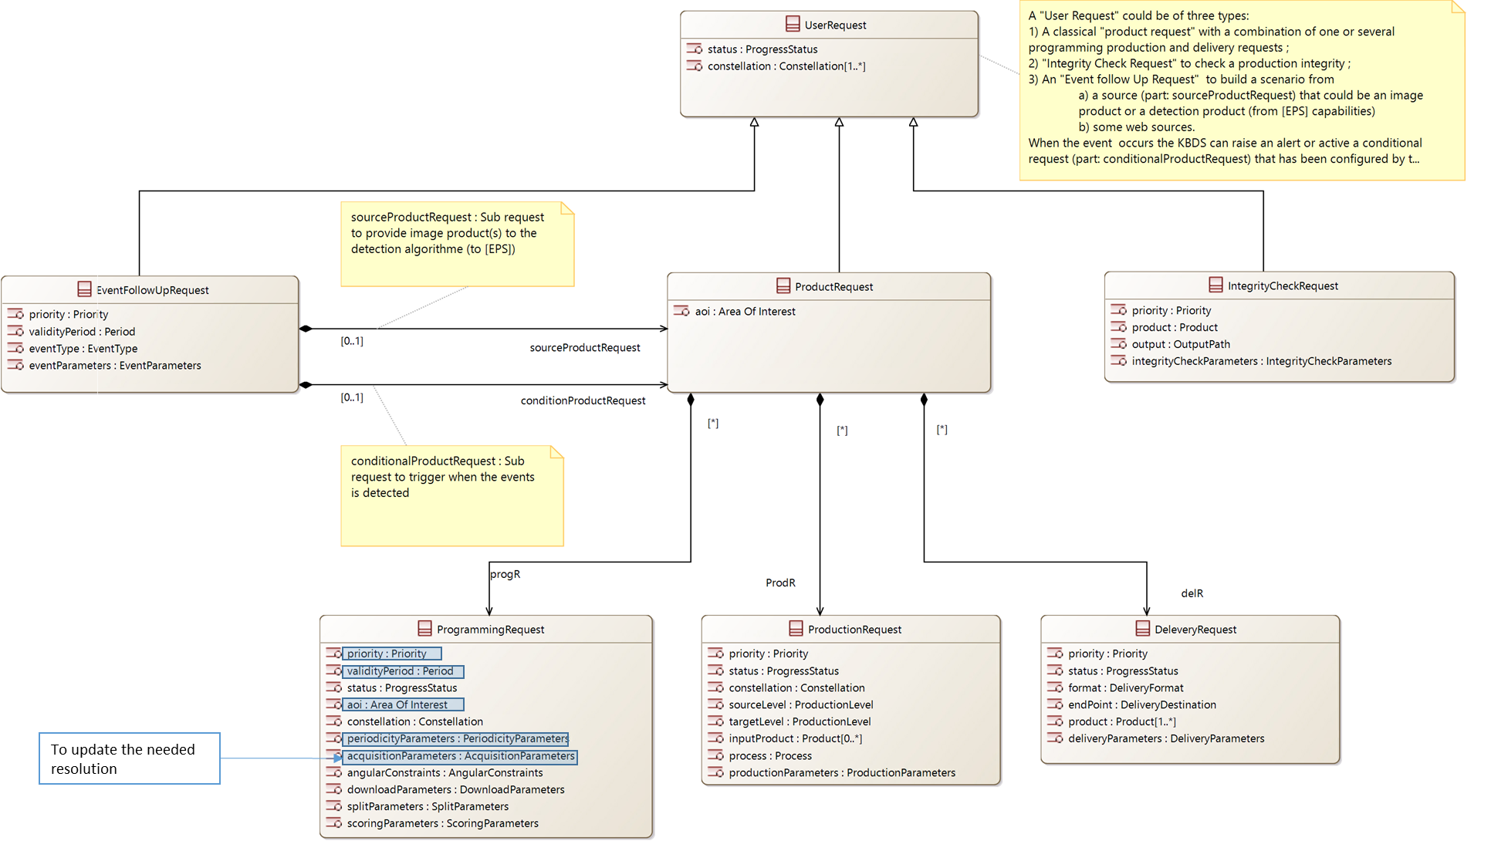

## Main functions

* Build knowledge from external sources as web
* Make decisions on mission programmation

## Detailled functions

* Collect data from external sources as web
* Enrich images metadata
* Detect events from external sources as web
* Detect events from products (images and metadata)

## Interfaces

[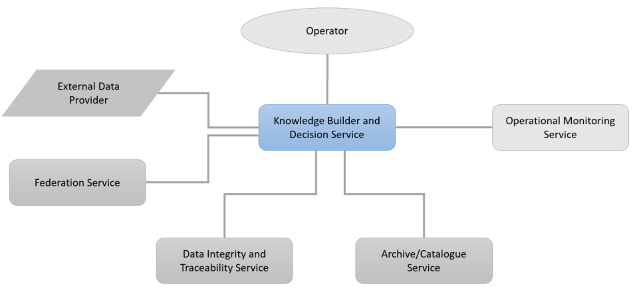](https://wiki-external.thalesaleniaspace.fr/download/attachments/296324115/KBDS.pptx?api=v2&modificationDate=1680192064000&version=2)

(info) See the "ICD Master" for the interfaces details

# (MAPQS) Machine-learning Application Production & Quality Service

## Overall description

The Machine-learing Application Production & Quality Service (MAPQS) domino regroups the tools for managing analytics (AI-based algorithms working on satellite images) all along their lifecycle. It goes from understanding the problem to designing a solution up to assessing and ensuring operational performance through updates and corrections.

## Main functions

* Monitor AI algorithms performances in operational processing chains
* Enrich training datasets with operational and re-train low-performances models
* Evaluate and compare models performances
* Deliver new models in processing chains
* Tag and correct bad quality operation prediction (ground truth generation)

## Interfaces

[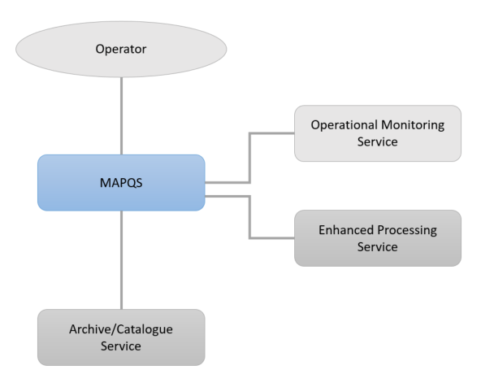](https://wiki-external.thalesaleniaspace.fr/download/attachments/300548276/MAPQS.pptx?api=v2&modificationDate=1680192897000&version=3)

[MAPQS.pptx](https://wiki-external.thalesaleniaspace.fr/download/attachments/300548276/MAPQS.pptx?api=v2&modificationDate=1680192897000&version=3)

(info) See the "ICD Master" for the interfaces details

# (MPS) Mission Programming Service

## Overall description

The Mission Programming Service (MPS) domino is in charge of elaborating the satellite(s) mission plan of one sovereign system. It gathers as well functions for the calculation of the satellite(s) mission plan, as functions for the management of mission plan follow-up (uploading, execution…). The MPS is also in charge of managing the Programming Requests of one sovereign system. It gathers as well basic functions for the Programming Requests storage and status management, as advanced ones for the feasibility study or for the mission plan calculation.

## Main functions

* Programming Request submission, modification, cancelation, and follow-up
* Programming Request analysis (intrinsic feasibility)
* Selection of Programming Requests candidate for Mission Plan calculation
* Computation of satellite(s) Mission Plan (including validation)
* Mission Plan upload follow-up
* Synchronisation with received segments
* Synchronisation with on-board state (memory status and effective downloads and on-board anomaly)

## Interfaces

[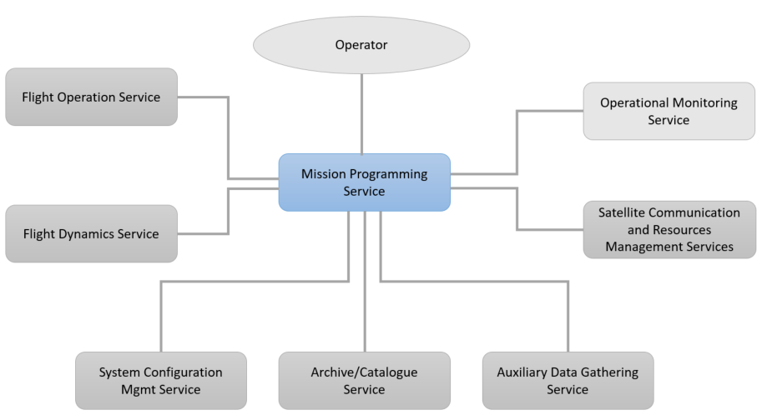](https://wiki-external.thalesaleniaspace.fr/download/attachments/296324172/MPS.pptx?api=v2&modificationDate=1680246111000&version=3)

[MPS.pptx](https://wiki-external.thalesaleniaspace.fr/download/attachments/296324172/MPS.pptx?api=v2&modificationDate=1680246111000&version=3)

(info) See the "ICD Master" for the interfaces details

# (OMS) Operational Monitoring Service

## Overall description

The Operational Monitoring Service (OMS) domino :

* Regroups the services needed to ensure the proper functioning of the system (ground segment, space segment, external providers...)
* Provides access to all other dominoes’ performance KPI (bandwidth, budget…) and displays and logs (on a regular basis or on demand) the metrics defined by the domino’s owners.
* Offers the means to investigate a contingency using AI (cognitive assistance). It provides, to operator and AI, access to all other dominoes for investigation.

## Main functions

* Display live monitoring on screen wall and on operators' dedicated screens
* Management of alarm toward operator on duty
* Centralize major logs, technical notifications and alarm
* Analyse the anomalies (based on Cognitive Assistant algorithm)
* Provide operation procedure to operators
* Build reports

This domino integrates the E2E Performance Monitoring functions :

* Display live monitoring on screen wall and on operators’ dedicated screens
* Management of performance-related alarm toward operator on duty
* Centralize performance logs and performance alarm
* Build performance reports

## Interfaces

[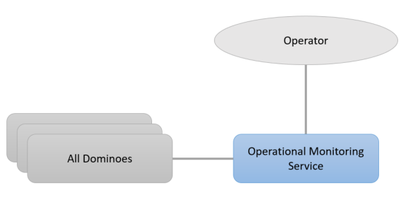](https://wiki-external.thalesaleniaspace.fr/download/attachments/296324397/OMS.pptx?api=v2&modificationDate=1680246717000&version=3)

[OMS.pptx](https://wiki-external.thalesaleniaspace.fr/download/attachments/296324397/OMS.pptx?api=v2&modificationDate=1680246717000&version=3)

(info) See the "ICD Master" for the interfaces details

(info) See also the [Actor](https://wiki-external.thalesaleniaspace.fr/display/DEOP/Actors) page, to have more details about the operator's roles.

# (PPS) Primary Processing Service

## Overall description

The Primary Processing Service domino (PPS) is responsible for the Pivot level (L2 for optical sensors) product generation.

## Main functions

* Perform TMI  deciphering
* Perform systematic processing until pivot level from input CADUs
* Perform on-demand (re)processing according to processing services exposed on PPS capabilities catalogue (either from CADU or from other intermediate level)

## Interfaces

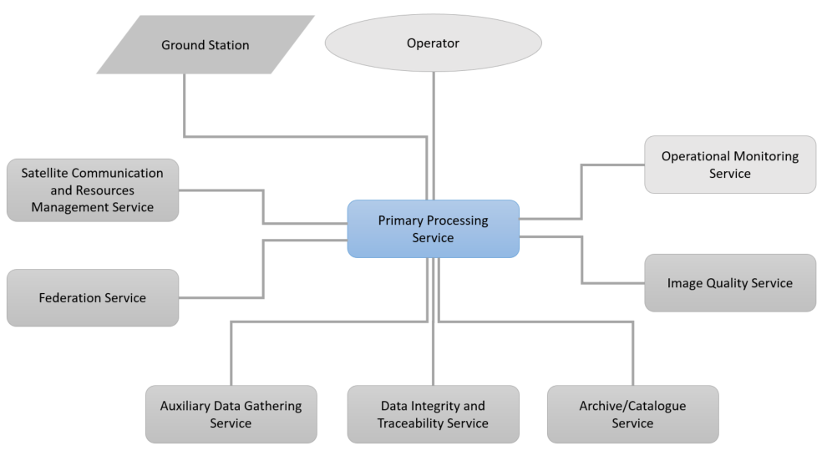

[PPS.pptx](https://wiki-external.thalesaleniaspace.fr/download/attachments/296324206/PPS.pptx?api=v2&modificationDate=1680247041000&version=4)

(info) See the "ICD Master" for the interfaces details

# (SCMS) System Configuration Mgmt Service

## Overall description

The System Configuration Mgmt Service (SCMS) domino gathers the storage of the common system configuration parameters, and their dissemination to the dominoes which need them.

## Main functions

* Manage system configuration
* Dissemination of needed system configuration

## Interfaces

[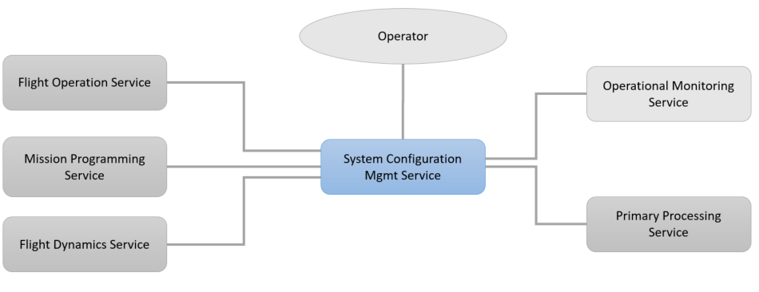](https://wiki-external.thalesaleniaspace.fr/download/attachments/296324373/SCMS.pptx?api=v2&modificationDate=1680247403000&version=7)

[SCMS.pptx](https://wiki-external.thalesaleniaspace.fr/download/attachments/296324373/SCMS.pptx?api=v2&modificationDate=1680247403000&version=7)

(info) See the "ICD Master" for the interfaces details

# (SCRMS) Satellite Communication and Resources Management Service

## Overall description

The primary role of Satellite Communication and Resources Service (SCRMS) is to allow a flexible management of the satellite communications either through ground station network, based on owned or/and GSaaS stations. The system communications encompasses both TM-TC and ITM flow, and can be allocated routinely for regular needs (Periodic Routine Planification) or for additional needs as solicited by complementary mission needs.

For consistency with the communication slot allocation, the SCRMS also manages the allocation of various orbital slots (referred as “Resources” in the SCRMS naming) as needed by the system operations, such as satellite manoeuvers (OCM, ACM slots), technological operations (“techno slot”) or maintenance (“forbidden slot”).

SCRMS scope is multi-mission by centralizing the schedule of the whole orbital usage, for each supported mission.

## Main functions

* Allocate in an optimized manner the communication slots matching the system needs (TM-TC and ITM)
* Solve the conflicts on the whole orbital slots (resources) as well as on multi-mission stations (owned)
* Schedule and set-up communications contacts with each owned Ground Stations
* Book and set-up communications contacts by interaction with the GSaaS providers
* Maintain the system slot schedule, as needed for satellite manoeuver, techno operations, or forbidden
* Provide up-to-date ephemeris data for contact exploitation (with mission and ground stations)
* Allow the level-2 operator to configure the SRCMS : ground stations network, routine plan and additional contact profile

## Interfaces

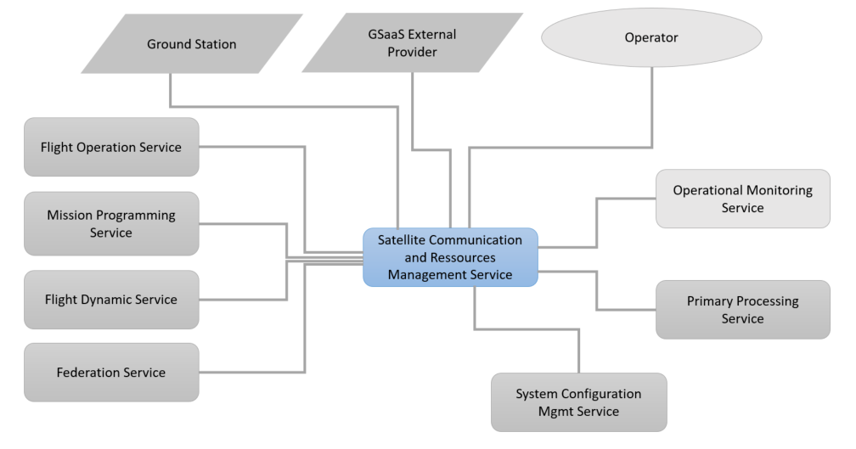

[SCRMS.pptx](https://wiki-external.thalesaleniaspace.fr/download/attachments/296324301/SCRMS.pptx?api=v2&modificationDate=1680513257000&version=7)

(info) See the "ICD Master" for the interfaces details

# (SMS) Security Monitoring Service

## Overall description

The Security Monitoring Service (SMS) domino regroups the security monitoring and task schedule: certificate management, software update, OS update. On specific topics, it can scan public information for security breaches and inform the security manager.

## Main functions

* Display security task schedule (not mandatory)
* Management of security alarm toward the Security Manager
* Log the security alarms

## Interfaces

[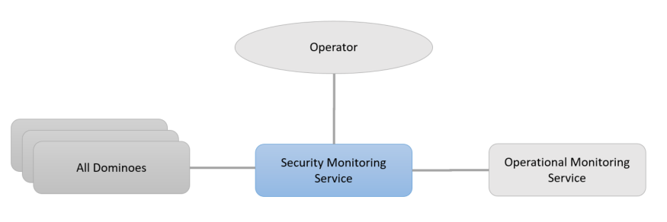](https://wiki-external.thalesaleniaspace.fr/download/attachments/296324354/SMS.pptx?api=v2&modificationDate=1680248422000&version=4)

[SMS.pptx](https://wiki-external.thalesaleniaspace.fr/download/attachments/296324354/SMS.pptx?api=v2&modificationDate=1680248422000&version=4)

(info) See the "ICD Master" for the interfaces details

# (SSS) Satellite Simulator Service

## Overall description

The Satellite Simulator Service (SSS) domino simulate the behavior if the satellite for training or validation.

## Main functions

* Simulate the satellite behaviour

## Interfaces

[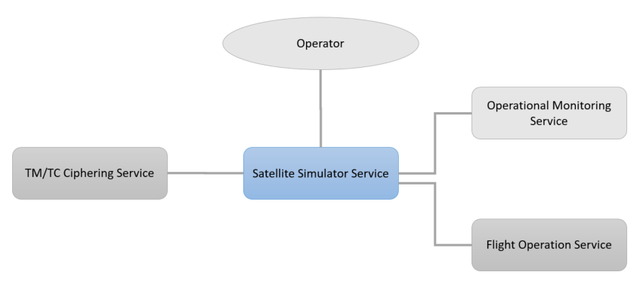](https://wiki-external.thalesaleniaspace.fr/download/attachments/296324337/SSS.pptx?api=v2&modificationDate=1680248643000&version=2)

[SSS.pptx](https://wiki-external.thalesaleniaspace.fr/download/attachments/296324337/SSS.pptx?api=v2&modificationDate=1680248643000&version=2)

(info) See the "ICD Master" for the interfaces details

# (UAS) User Access Service

## Overall description

The User Access Service (UAS) domino is in charge of providing the user with MMI means for accessing the system and perform the follow-up of the requests. It gathers as well MMI or visualisation functions, as cartographic data services, end-user account management and notifications.

## Main functions

* Catalogue products browsing and visualisation
* Capabilities consultation
* User Request definition, activation and follow-up
* Enhanced product (results) display
* End-user notification
* End-user account management (rights/preferences/context)

## Interfaces

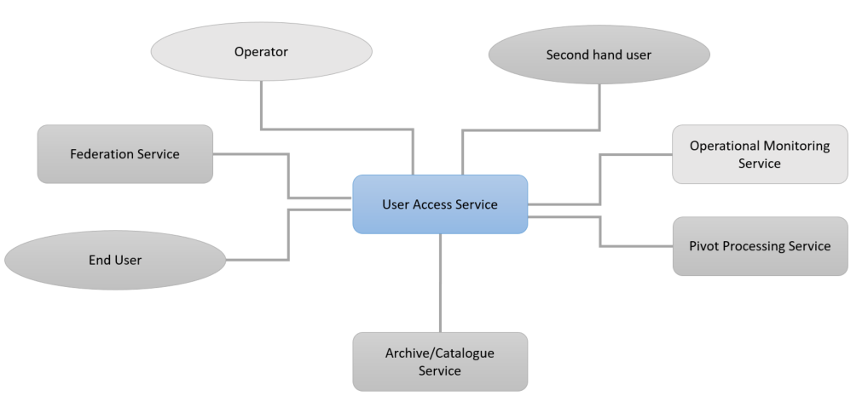

[UAS.pptx](https://wiki-external.thalesaleniaspace.fr/download/attachments/296324430/UAS.pptx?api=v2&modificationDate=1680249457000&version=6)

(info) See the "ICD Master" for the interfaces details