Use cases

Domino-X Earth Observation Project

Exported on 2023-11-17 16:09:43

Table of Contents

1 Main use cases 5

2 Use-case derivation (justification) 6

2.1 Base use-cases 6

2.2 Top-level use-cases 6

2.3 Search in catalog (UC-010) 7

2.4 Define a user request and follow-up (UC-020) 7

2.4.1 Book GS contacts (UC-021) 7

2.4.2 Order programming requests (UC-022) 7

2.4.3 Planify mission (UC-023) 8

2.4.4 Command satellite (UC-024) 8

2.4.5 Process products (UC-025) 9

2.4.6 Event follow-up and automatic reprogramming (UC-026) 9

2.5 Receive products (UC-030) 9

2.6 Check trustability (UC-040) 10

2.7 Maintain the system (UC-090) 10

2.7.1 Maintain security (UC-091) 11

2.7.2 Maintain performance (UC-092) 11

2.7.3 Maintain technically (UC-093) 12

3 Search in catalog (UC-010) 13

3.1 UC-010-A - Browsing Catalogue Product 13

3.2 UC-010-A - Harvesting External Catalogues 13

4 Manage GS contacts (UC-021) 14

4.1 UC-021-A - Book routine contacts 14

4.2 UC-021-B - Book an additional contact (common part) 14

4.3 UC-021-B.1 - Book an additional contacts to fulfil urgent requests 14

4.4 UC-021-B.2 - Book an additional TM/TC contact to plan an urgent collision avoidance manoeuver 15

4.5 UC-021-B.3 - Book an additional  TM/TC contact to investigate an on board anomaly 16

4.6 UC-021-B.4 - Book an additional ITM contact to fulfil an increased download capacity need 17

5 Order programming requests (UC-022) 18

5.1 UC-022-A - Acquire an image 18

5.2 UC-022-B - Monitor a Site & Notify 19

5.3 UC-022-C - Cover a large Area 21

6 UC-023-A - Mission Plan Calculation and Follow-up 23

7 Command satellite (UC-024) 24

7.1 UC-024-A - CGS activities preparation 24

7.2 UC-024-B - CGS pass processing activities 24

7.3 UC-024-C - CGS post pass activities 25

8 Process products (UC-025) 26

8.1 UC-025-A - Systematic processing 26

8.2 UC-025-B - On-Demand Processing-Reprocessing 26

8.3 UC-025-C - External Processing 27

9 UC-026-A - Event follow-up and automatic reprogramming (work in progress) 28

10 Receive products (UC-030) 29

11 Check trustability (UC-040) 30

11.1 [ES] UC-040-A - Internal data integrity verification (hash) 30

11.2 [ES] UC-040-B - External data integrity verification (tattoo) 30

11.3 [ES] UC-040-C - Data traceability 30

12 [ES] UC-090-A - Routine monitoring 32

13 Maintain performance (UC-092) 33

13.1 [ES] UC-092-A - Fine-tune machine-learning applications 33

13.2 [ES] UC-092-B - Retrieve IQ Data (Common part) 33

13.3 [ES] UC-092-B - Monitor Image Quality 34

13.4 [ES] UC-092-B - Calibrate Image Chain 34

13.5 UC-092-D - Administrate the SCRMS 35

14 Maintain technically (UC-093) 36

14.1 [ES] UC-093-A - Manage technical contengencies 36

14.2 [ES] UC-093-A - Manage Image Quality Contengencies 36

14.3 [ES] UC-093-B - Maintenance commands 37

15 Others 38

15.1 [ES] UC-XXX-X - External processing follow up 38

15.2 [ES] UC-XXX-X - On-Demand Contingency Reprocessing 38

15.3 [ES] UC-XXX-X - UAS/Catalogue administration 39

Each Use Case (UC) is defined by :

* An identifier,
* A name
* Actors interacting with the UC (or main participants)
* A short description
* An initial state
* A final state
* Trigger

# Main use cases

The diagram below presents the main use cases of Domino-X ground segment.

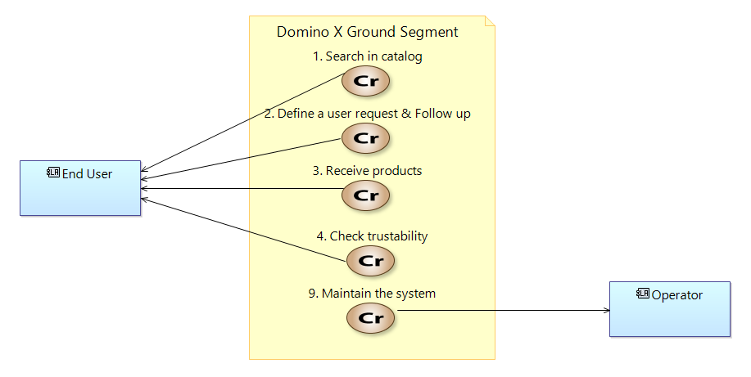

*Diagram "[CRB] Base Use Cases" extracted from Capella*

# Use-case derivation (justification)

## Base use-cases

The base use-cases correspond to the main functions offered by the system of interest.



*Diagram [CRB] Base Use Cases*

## Top-level use-cases

This derivation is quite artificial, but has the benefit to list the main functions expected from a Ground Segment.

The next chapters will described each one of these use-cases into use-cases that can be modelised into Capella.

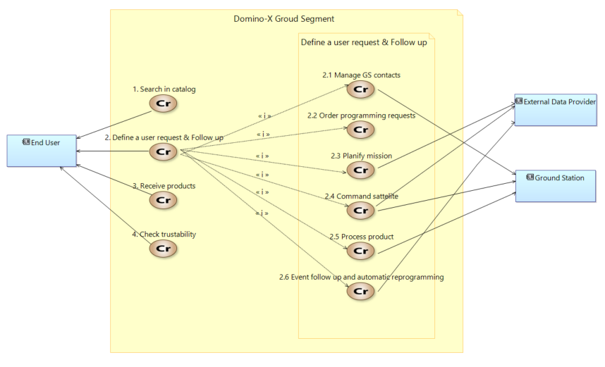

*Diagram "[CRB] Top-level use cases (offered to end-user)"*

## Search in catalog (UC-010)

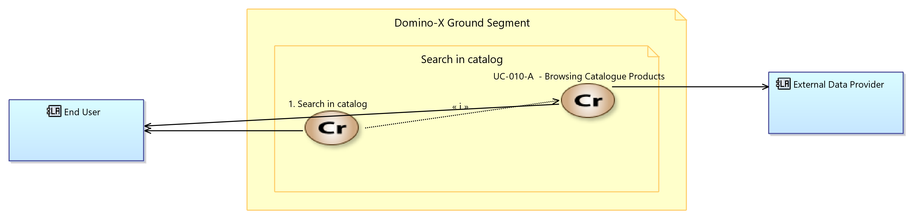

*Diagram "[CRB] Search in Catalog" extracted from Capella*

## Define a user request and follow-up (UC-020)

### Book GS contacts (UC-021)

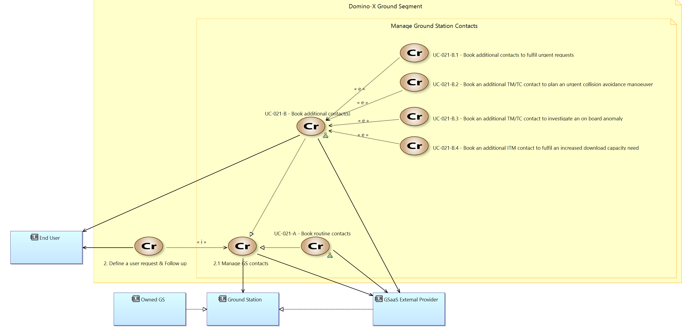

*Diagram "[PlantUML] Book GS contacts"*

### Order programming requests (UC-022)

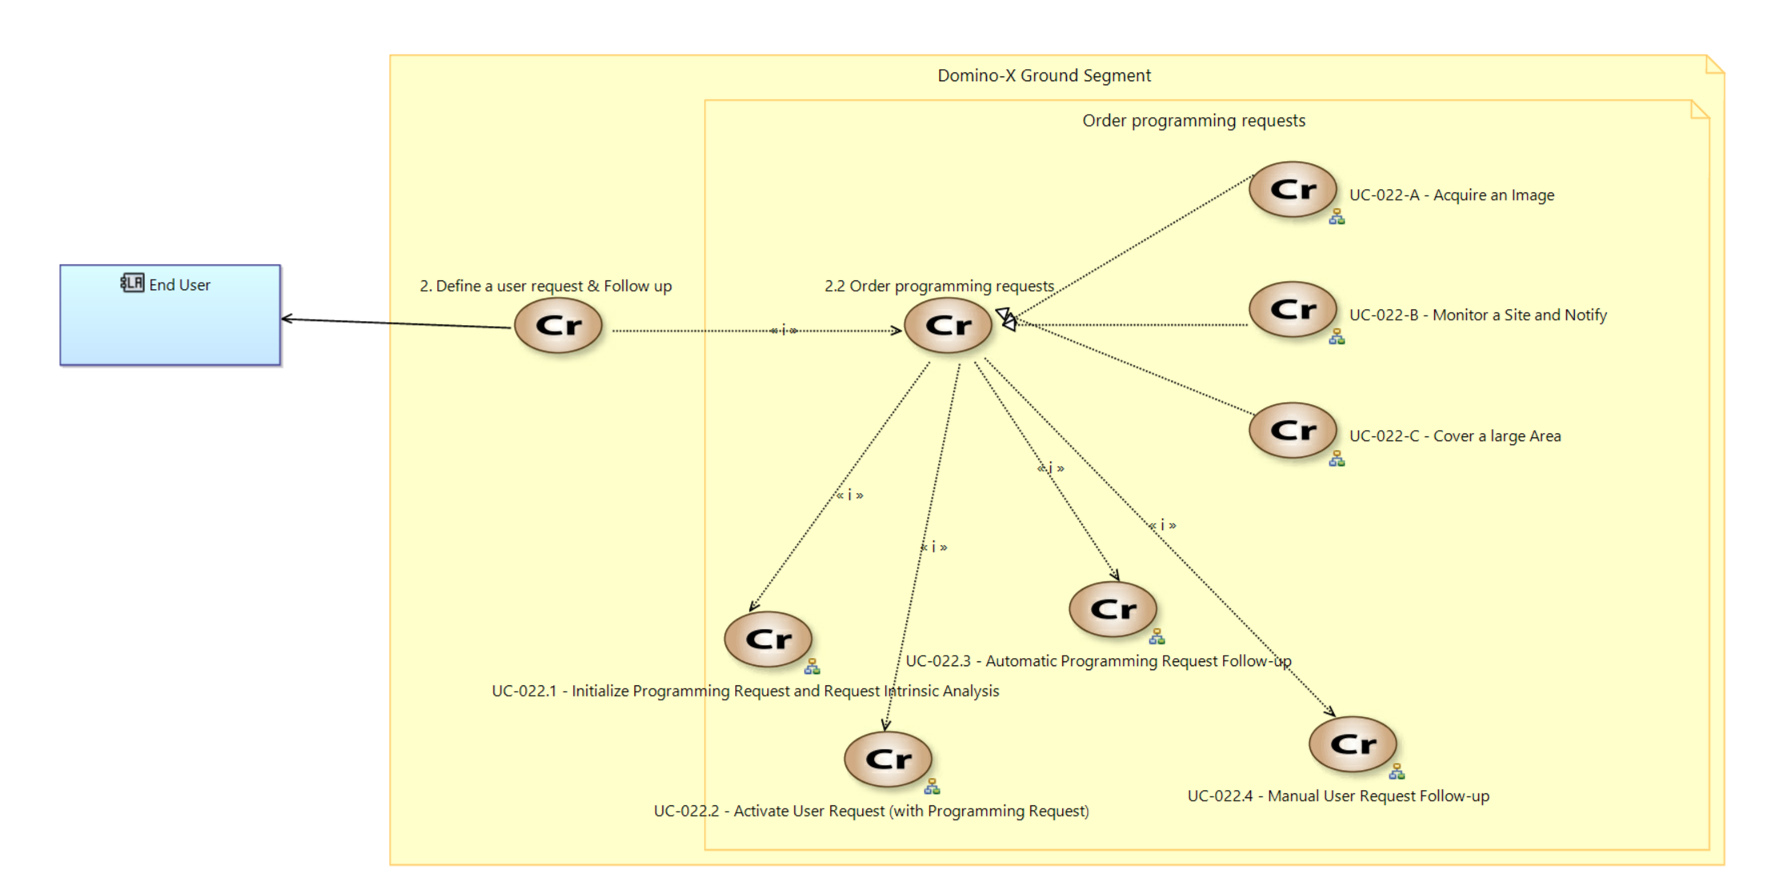

*Diagram "[CRB] Order programming requests"*

### Planify mission (UC-023)

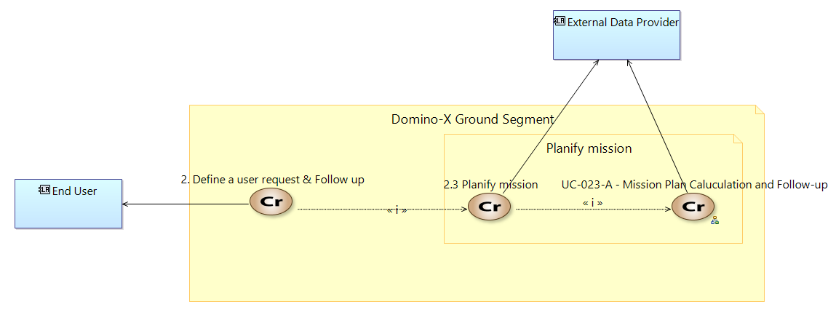

*Diagram "[CRB] Planify mission"*

### Command satellite (UC-024)

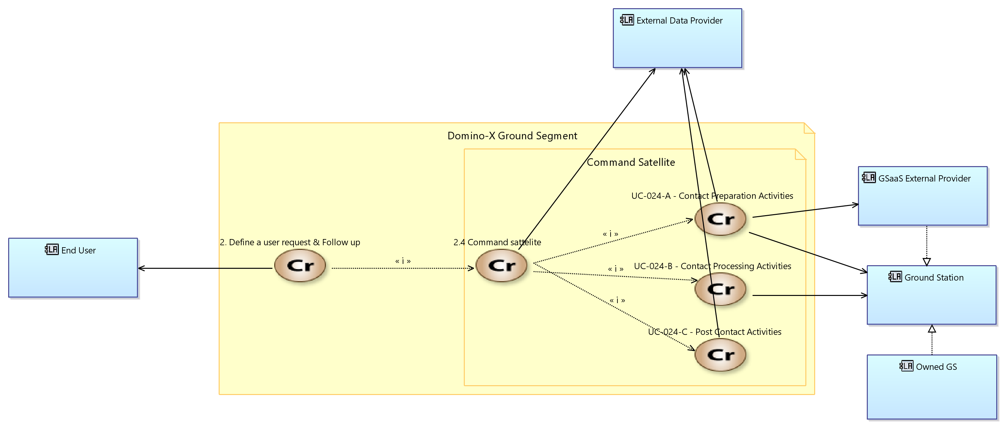

*Diagram "[CRB] Command Satellite"*

### Process products (UC-025)

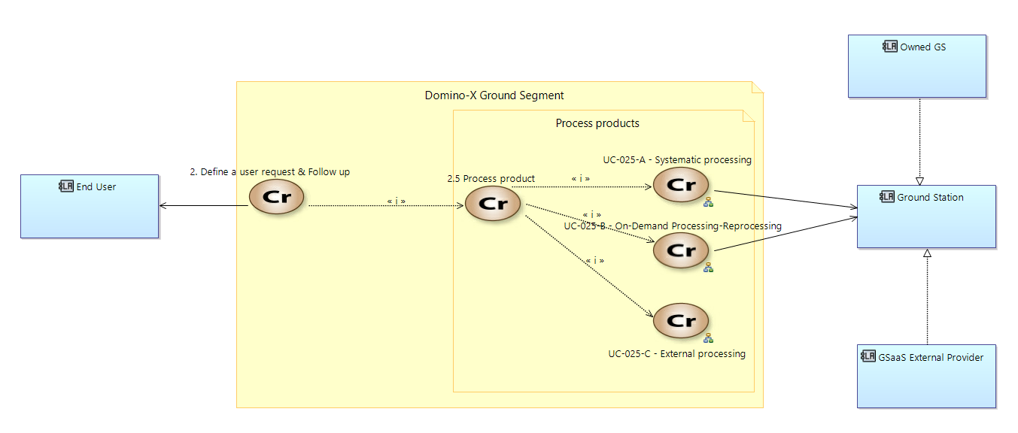

*Diagram "[CRB] Process products"*

### Event follow-up and automatic reprogramming (UC-026)

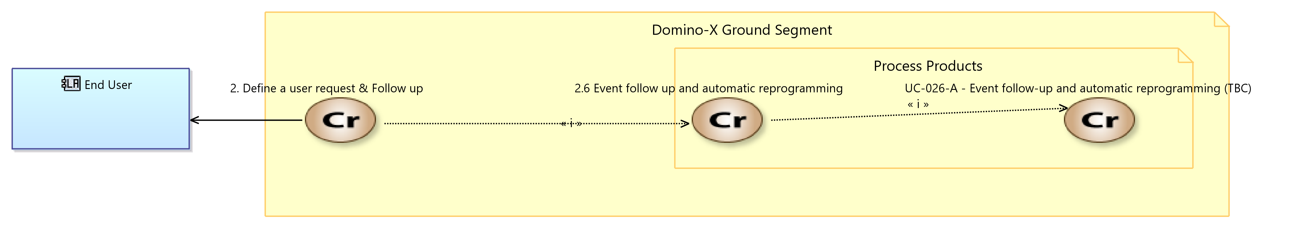

*Diagram "[CRB] Event follow-up and automatic reprogramming"*

## Receive products (UC-030)

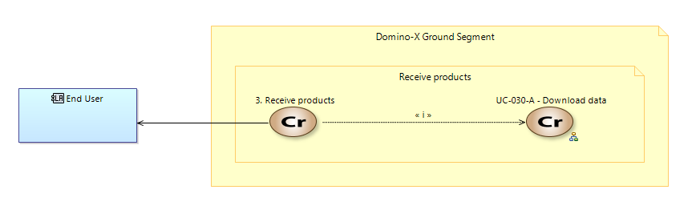

*Diagram "[CRB] Receive products"*

## Check trustability (UC-040)

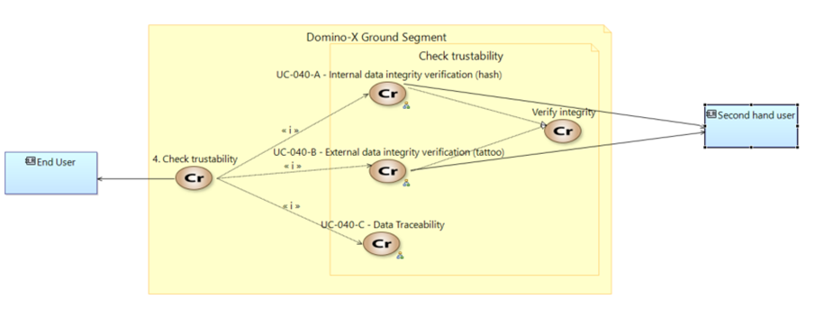

*Diagram "[CRBD] Check trustability Use-case"*

## Maintain the system (UC-090)

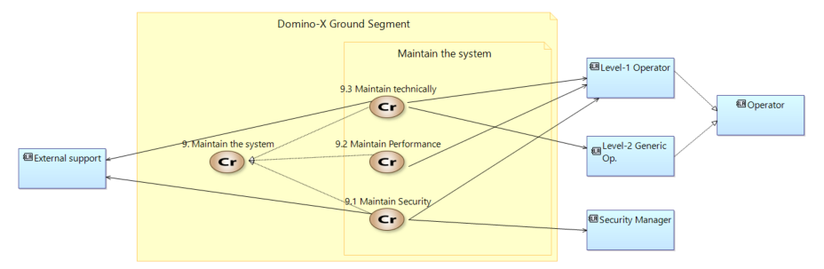

*Diagram "[CRB] Top-level use cases (for maintenance)"*

### Maintain security (UC-091)

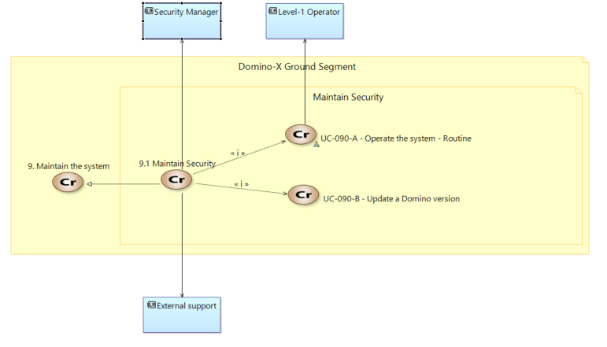

*Diagram "[CRB] Maintain Security"*

### Maintain performance (UC-092)

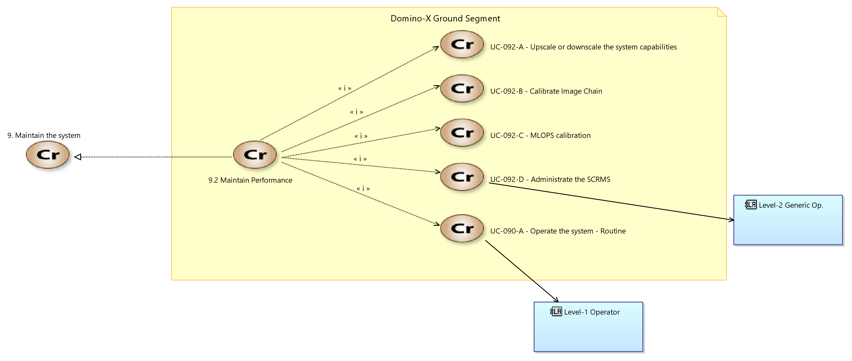

Diagram "[CRB] Maintain Performance"

### Maintain technically (UC-093)

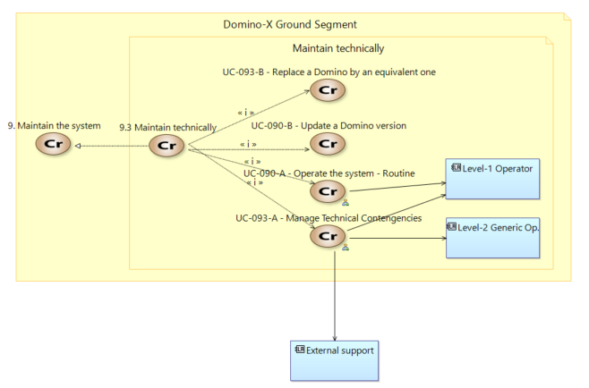

*Diagram "[CRB] Maintain technically"*

# Search in catalog (UC-010)

## UC-010-A - Browsing Catalogue Product

|  |  |
| --- | --- |
| **ID** | UC-010-A |
| **Name** | Browsing Catalogue Products |
| **Main Participants** | End User, UAS, ACS and KBDS |
| **Short Description** | This scenario presents the catalogue browsing by the End-User.  The catalogue data are products (images) metadata stored in ACS and thematics data (points of interest or events) stored in KBDS. |
| **Initial state of the system** | UAS, ACS and KBDS dominoes are fully configured and operational.  Input data for the catalogue browsing: End-User command with Formated search (several parameters) or Natural Language search (one sentence). |
| **Final state of the system** | Output data for the catalogue browsing:  Response associated to search (same format for formated search or natural language search):  Products catalogue file (if available)  and  Thematics catalog file (if available and requested) |
| **Trigger** | End-User command |

(info) See Capella sequence diagram: [ES] UC-010-A - Browsing Catalogue Product

## UC-010-A - Harvesting External Catalogues

|  |  |
| --- | --- |
| **ID** | UC-10-A |
| **Name** | Harvesting External Catalogues |
| **Main Participants** | [INTS], External-Catalogues, and optionally  [ACS]. |
| **Short Description** | This scenario presents the harvesting of external catalogues. Product Metadata are harvested periodically. Optionally, products can be also harvested and stored in the [ACS]. |
| **Initial state of the system** | [INTS] (and optionally [ACS]) dominoes are fully configured and operational. |
| **Final state of the system** | The metadata of the external catalogue are harvested and catalogued into the [ACS]. If product harvesting is activated, the external products are store in pivot format into the [ACS]. |
| **Trigger** | Internal scheduling of [INTS] |

(info) See Capella sequence diagram: [ES] UC-010-A - Harvesting External Catalogues

# Manage GS contacts (UC-021)

## UC-021-A - Book routine contacts

|  |  |
| --- | --- |
| **ID** | UC-021-A |
| **Name** | Book routine contacts |
| **Main Participants** | Level-2 Operator |
| **Short description** | The system compute, select and books TM/TC and ITM contacts to match regular routine operations over several days/cycles (according the per-mission contact needs configured into the [SCRMS]). |
| **Initial state of the system** | The GS is started, and contains at least one operable satellite  The [SCRMS] is configured. In particular, the mission routine profile and the accessible ground stations (owned or GSaaS) are defined, in accordance with contractual agreement |
| **Final state of the system** | * The [SCRMS] has booked the TM/TC and ITM contacts matching the "routine plan model" * The communication schedule is updated accordingly * The global schedule of the [SCRMS] is internally updated and available for other dominoes   *For GSaaS: The booking success rate is guaranteed by the contractual agreement*  *Owned Ground Station allocation does not require booking but a consistent scheduling to manage multi-mission usage.* |
| **Trigger** | Internal. Automatic via (configurable) per-mission periodic timer |

NB : Conflicts on the owned stations may appear (if multi-mission):

* The system select one solution (optimized?)
* The level-2 operator for resolution

(info) See Capella sequence diagram: [ES] UC-021-A - Book routine contacts

## UC-021-B - Book an additional contact (common part)

This use-case is applied for all the "additional contact" use-cases. It describes how the additional contact is booked by the SCRMS.

(info) See Capella sequence diagram: [ES] UC-021-B - Book an additional Contact (common part)

## UC-021-B.1 - Book an additional contacts to fulfil urgent requests

|  |  |
| --- | --- |
| **ID** | UC-021-B.1 |
| **Name** | Book an additional contacts to fulfil urgent requests |
| **Main Participants** | * Level-2 Ground Station operator (optional) * GSaaS provider * SCRMS * MPS |
| **Short description** | The end-user has urgents acquisition need which implies to add a ITM or TM/TC or both contacts. The Federation Service is in charge of analysing periodically (or based on an internal schedule) the urgent user requests and from the Mission Programming Service results ask for additional contacts if needed. Internally, [FS] aggregates the contacts needs when is possible and request them to the [SCRMS]. There could be both ITM and TM/TC contacts |
| **Initial state of the system** | The GS is started, and contains at least one operable satellite  The [SCRMS] should have access to dynamically bookable Ground Station (through a GSaaS provider) |
| **Final state of the system** | In case of success:   * The [SCRMS] has booked new contact that fulfil the end-user need * The global schedule of the [SCRMS] is internally updated taking this new contact into account   In case of failure (impossible to add a new contact):   * The programing requests are updated with a failure status |
| **Trigger** | [FS] Domino, with the function "Manage Urgent Request" |

(info) See Capella sequence diagram: [ES] UC-021-B.1&B.5&B.6 - Book an additional TM/TC & ITM contacts to fulfil urgent requests

## UC-021-B.2 - Book an additional TM/TC contact to plan an urgent collision avoidance manoeuver

|  |  |
| --- | --- |
| **ID** | UC-021-B.2 |
| **Name** | Book an additional S-Band contact to plan an urgent collision avoidance manoeuver |
| **Main Participants** | * Level-2 Ground Station operator (optional) * GSaaS provider |
| **Short description** | The GS updates the active plan to enable a very urgent CAM. A new TM-TC slot is booked accordingly (complying the timeline need) to allow the upload a a new plan. In this case additional TM/TC contact is express by the [FDS] domino with a satellite, a time intervalle with as soon as possible clause, a minimum duration. |
| **Initial state of the system** | The GS is started, and contains at least one operable satellite  The [SCRMS] should have access to:   * dynamically bookable Ground Station (through a GSaaS provider) * a collision computation system (as the US 18th Space Defense Squadron) |
| **Final state of the system** | In case of success:   * The [SCRMS] has booked a new TM/TC contact that fulfil the [FDS] need * The global schedule of the [SCRMS] is internally updated and available for other dominoes |
| **Trigger** | [FDS] function "Compute Collision Avoidance Manoeuvre"  A trigger of potential collision alert is raised, and the  [FDS] domino computes a manoeuver (at short term) that cannot be uploaded with the currently planed contacts, and then  [FDS] domino requests a new TC slot to upload this manoeuver plan. |

(info) See Capella sequence diagram: [ES] UC-021-B.2 - Book an additional TM/TC contact to plan an urgent collision avoidance manoeuver

## UC-021-B.3 - Book an additional  TM/TC contact to investigate an on board anomaly

|  |  |
| --- | --- |
| **ID** | UC-021-B.3 |
| **Name** | Book an additional TM/TC contact to investigate an on board anomaly |
| **Main Participants** | * Level-2 Ground Station operator * GSaaS provider |
| **Description** | After an on-board anomaly is raised, the GS automatically planed some additional contacts to allow the Level-2 operators to investigate.  In this case additional TM/TC contact is express by the [FOS] domino with a satellite, a time intervalle with a clause specifiying that all the available contact slots are wanted, a minimum duration. |
| **Initial state of the system** | The GS is started, and contains at least one operable satellite  The [SCRMS] should have access to dynamically bookable Ground Station (through a GSaaS provider) |
| **Final state of the system** | In case of success:   * The [SCRMS] has booked a new TM/TC contact that fulfil the [FOS] need * The global schedule of the [SCRMS] is internally updated and available for other dominoes |
| **Triggers** | [FOS] function "Manage TM/TC contacts"  The [FOS] detects in the TM that an on-board anomaly occurred that will need an operator analysis, and requests the [SCRMS] domino to have more contacts. |

(info) See Capella sequence diagram: [ES] UC-021-B.3 - Book an additional TM/TC contact to investigate an on board anomaly

## UC-021-B.4 - Book an additional ITM contact to fulfil an increased download capacity need

|  |  |
| --- | --- |
| **ID** | UC-021-B.4 |
| **Name** | Book an additional ITM contact to fulfil an increased download capacity need |
| **Main Participants** | * SCRMS * MPS * GSaaS provider |
| **Short description** | The system books additional ITM contacts to provide more download capacity in accordance with a temporary acquisition workload increase.  In this case, [MPS] requests additional ITM contact. It is express, a time interval , a minimum duration for a given satellite. |
| **Initial state of the system** | • The GS is started, and contains at least one operable satellite • The [SCRMS] should have access to dynamically bookable Ground Station (through a GSaaS provider) • The GS should have at least one scheduled TM-TC slot before the new download ITM contact (to allow uploading a new mission plan to the spacecraft) |
| **Final state of the system** | In case of success:     • The [SCRMS] has booked a new ITM contact that fulfil the end-user need      • The global schedule of the [SCRMS] is internally updated and available for other dominoes In case of failure (impossible to add a new contact):  The programing requests are updated with a failure status |
| **Trigger** | [MPS] detects the need of additional ITM contact due to either more and more impossibilities of the satellite to download the acquisition within their validity period or the programming of new acquisition is delayed because the satellite memory os overloaded. |

(info) See Capella sequence diagram: [ES] UC-021-B.4 - Book an additional ITM contact to fulfil an increased download capacity need

# Order programming requests (UC-022)

## UC-022-A - Acquire an image

|  |  |
| --- | --- |
| **ID** | UC-022-A |
| **Name** | Acquire an image |
| **Main Participants** | End User, [UAS], [FS], [MPS], [INTS], [ADGS] |
| **Short Description** | **Programming request definition**   * As an End User, I want to ask for a new image acquisition of my area, by defining a Programming Request inside my User Request (See - [Definitions](https://wiki-external.thalesaleniaspace.fr/display/DEOP/Definitions) : Programming Request parameters  ). For a Simple Image Acquisition the following parameters have specific values :   + Periodic flag = No * The emergency case is covered by the definition of the following parameter :   + Priority corresponds to : the highest possible level of priority   **Providers selection**   * As an End User, I want to select a set of providers to be addressed, among a list of federated providers and my sovereign space segment, for the processing of my Programming Request. * As an End User, I want the system to automatically filter and show me the providers that do match with my criteria (list of authorised providers, GSD…), so that I can modify these criteria.   **Production and delivery requests definition**   * As an End User, I want the system to perform automatically and systematically production up to primary products with production parameters default values. * As an End User, I want to specify the delivery parameters of the acquired images by defining a Delivery Request inside my User Request (See Delivery Request parameters).   **Programming request analysis and validation**   * As an End User, I want to ask the system to perform an indicative analysis of feasibility of my User Request choosing to take into account or not the workload of sovereign providers, and to present me the soonest possible acquisition. * As an End User, optionally I want to modify my Programming Request parameters and iterate on the previous step. * As an End User, I want to validate my User Request so that the system takes it into account.   **Programming request processing**   * As an End User, I want the system to choose automatically the provider allowing the soonest acquisition of a new image corresponding to my Programming Request. This provider can correspond to an external provider if it allows to get the soonest acquisition. Several providers can be tried in case of unsuccessful programming of an initial provider.   **Request follow-up**   * As an End User, I want to set my preferred way to be notified (email/SMS/reports…) globally for all User Requests. * As an End User, I want to have notifications or request feedback from the system on the process of my User Request until product delivery. * As an End User, optionally I want to update some Programming Request parameters like the validity period, angular constraints, nebulosity threshold or priority. * As an End User, I want the system to save products in an archive (depending on the retention policy) so I can retrieve them later. * As an End User, optionally I want to retrieve products related to my User Request directly from the archive. * As an End User, optionally I want to cancel or complete manually my User Request so that the Programming Request will be no more considered by the providers. |
| **Initial state of the system** | * the GS is fully configured and operational * End User wants to acquire a single image |
| **Final state of the system** | * Single image archived and available for the End User (if successful answer) |
| **Trigger** | * End User request |

(info) See Capella sequence diagram: [ES] UC-022-A&B - Monitor a Site

## UC-022-B - Monitor a Site & Notify

Monitor a site and notify (from request to product delivery)

|  |  |
| --- | --- |
| **ID** | UC-022-B |
| **Name** | Monitor a Site & Notify |
| **Main Participants** | End User, [UAS], [FS], [MPS], [INTS], [ADGS] |
| **Short Description** | **Consultation of existing images**   * As an End User, I want to perform an evaluation of the current situation by retrieving  existing images of my site from federated systems (sovereign + external) : * See UCs : Browsing catalogue products, Download data  and On demand processing.   **Programming request definition**   * As an End User, I want to ask for new image acquisitions of my site by defining a Programming Request inside my User Request (See Programming Request parameters). For a Site Monitoring the following parameters have specific values:   + Periodic flag = Yes + periodicity + min offset between 2 acquisitions   + Geographical area corresponds to a small area * As an End User, I want to have the capacity to update a few User Request parameters during the validity period of a site monitoring, including stopping the monitoring request.   **Providers selection**   * See UC-022-A   **Production and delivery requests definition**   * See UC-022-A   **Programming request analysis and validation**   * As an End User, I want to ask the system to perform an indicative analysis of feasibility of my User Request choosing to take into account or not the workload of sovereign providers, and to present me the possible acquisitions on the first revisit periods of my site monitoring. * As an End User, optionally I want to modify my Programming Request parameters and iterate on previous step. * As an End User, I want to validate my User Request so that the system takes it into account.   **Programming request processing**   * As an End User, I want the system to choose automatically the *“best providers”* for the acquisitions of new images corresponding to my Programming Requests. *“Best providers”* mean sovereign providers in priority before external ones. * As an End User, I want the system to respect, as much as possible, the periodicity criteria of my Programming Request.   **Request follow-up**   * See UC-022-A |
| **Initial state of the system** | * The GS is fully configured and operational * End User wants to monitor a site |
| **Final state of the system** | * Site images archived and available for the End User (if successful answer) |
| **Trigger** | * End User request |

The following sequence diagram shows the main activities coming into play within this use case :

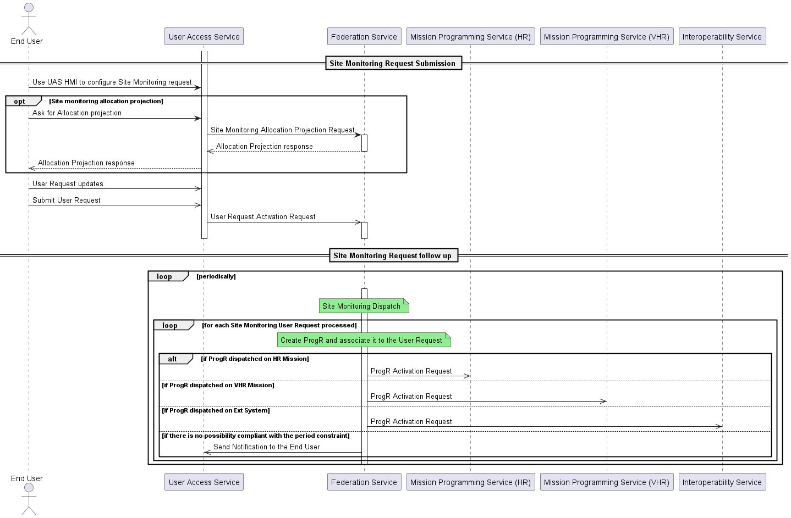

(info) See Capella sequence diagram: [ES] UC-022-A&B - Monitor a Site

## UC-022-C - Cover a large Area

|  |  |
| --- | --- |
| **ID** | UC-022-C |
| **Name** | Cover a large Area |
| **Main Participants** | End User, [UAS], [FS], [MPS], [INTS], [ACS] |
| **Short Description** | **Consultation of existing images**   * As an End User, I want to know which part of my areas are already covered by retrieving  existing images of my area from federated systems (sovereign + external) : * See UCs : Browsing catalogue products, Download data  and On demand processing * As an End User, I want to select some of the retrieved images, and ask the system to determine automatically the remaining area to acquire.   **Programming request definition**   * As an End User, I want to ask for new image acquisitions of my coverage initial area, or of the remaining to acquire area, by defining a Programming Request inside my User Request (See Programming Request parameters). For a Coverage the following parameters have specific values:   + Periodic flag = No   + Geographical area corresponds to: initial area or remaining to acquire area (large area)   **Providers selection**   * See UC-022-A   **Production and delivery requests definition**   * See UC-022-A   **Programming request analysis and validation**   * As an End User, optionally I want to ask the system to compute and present me all the potential unitary acquisitions of the providers corresponding to my Programming Request (Intrinsic Analysis). * As an End User, optionally I want to ask the system to compute and present me the most suitable provider for my Programming Request, with an indication of the coverage progress along the time (Coverage analysis) taking into account or not the current order book. * As an End User, optionally I want to modify my Programming Request parameters and iterate on 2 previous steps. * As an End User, I want to validate my User Request so that the system takes it into account.   **Programming request processing**   * As an End User, I want the system to perform entirely the coverage using the most suitable provider determined at previous step or automatically at User Request validation.   **Request follow-up**   * See UC-022-A * As an End User, optionally I want to ask the system to present me a re-assessment of the future progress of my coverage along the time. |
| **Initial state of the system** | * The GS is fully configured and operational * End User request |
| **Final state of the system** | * Large area images archived and available for the End User (if successful answer) |
| **Trigger** | * End User request |

(info) See Capella sequence diagram: [ES] UC-022-C - Cover a large Area

# UC-023-A - Mission Plan Calculation and Follow-up

|  |  |
| --- | --- |
| **ID** | UC-023-A |
| **Name** | Mission Plan Calculation and Follow-up |
| **Main Participants** | [SCRMS], [FDS], [FOS], [ADGS], [SCMS], [MPS], [ACS] |
| **Short Description** | This Use Case describes the mission planning of one sovereign system in charge of an homogeneous satellites constellation.  [FS] submits the Programming Requests to program/planify to the relevant [MPS] domino according the system selection. This selection can be done by the End User at the User Request submission or by [FS] in the case of a multi-system user request (ie. Site Monitoring User Request).  [MPS] is in charge of planifying the Programming Requests into the Mission Plan computed depending on its internal schedule. |
| **Initial state of the system** | The GS is fully configured and operational  [SCRMS] is able to provide TM/TC and ITM booked contacts, Satellite unavailability slots  [ADGS] is able to provide Ground weather forecast, IERS , Climato data  [FDS] is able to provide Predicted orbit data  [SCMS] is able to provide satellite reference orbits  There are some candidate programming requests submitted to the [MPS] to be planified |
| **Final state of the system** | Mission plan computed, validated and being available for the [FOS] ; A mission plan is dedicated to one satellite  Mission polarization plan computed and being available for the [SCRMS]  Follow up of candidate programming requests  Updated product metadata (request ID) into [ACS] after loop closure |
| **Trigger** | Automatic triggering following internal chronology of the [MPS] |

(info) See Capella sequence diagram: [ES] UC-023-A - Mission Plan Calculation and Follow-up

# Command satellite (UC-024)

## UC-024-A - CGS activities preparation

|  |  |
| --- | --- |
| **ID** | UC-024-A |
| **Name** | CGS activities preparation |
| **Main Participants** | External data provider |
| **Short Description** | This use case presents the CGS activies preparation before a TM/TC contact |
| **Initial state of the system** | System started, fully configured and operational  TM/TC DB imported from the [SCMS].  The satellite and/or system parameters are generally provided once at the start of the system lifetime . This may still happen a few times during the lifetime if updates are needed, but it is still a rare activity.  Predicted orbit data and Manoeuvre plan available for retrieval on the [FDS]  Mission plan available for retrieval on the [MPS]  TM-TC contacts and polarisation plan available |
| **Final state of the system** | TC Plan computed by the [FOS]  TM-TC contacts matching  with the TC Plan computed : TM-TC contacts booked and configured in order to  receive/transmit TM/TCs. |
| **Trigger** | Some time before a scheduled TM/TC contact., by the [FOS] internal orchestration |

(info) See Capella sequence diagram: [ES] UC-024-A - CGS activities preparation

## UC-024-B - CGS pass processing activities

|  |  |
| --- | --- |
| **ID** | UC-024-B |
| **Name** | CGS pass processing activities |
| **Main Participants** | FOS is the main actor |
| **Short Description** | Via the ground stations, the [TM/TC Ciphering Service] receives the encrypted TM from the satellite. It decrypts this TM and sends it to the [FOS]. The [FOS] sends the TCs in clear mode to the [TM/TC Ciphering service]. This latter service encrypts and transmits the TCs to the ground stations (to satellite).  In simulation mode, when the satellite and the ground-station is replaced by a simulator then the [TM/TC ciphering service] acts as a simple router. In this case :   * The TM transmitted by the satellite simulator is broadcast in clear mode to the [TM/TC Ciphering service] which is responsible for routing it to the [FOS]. * As for the [FOS], it transmits the TC in clear mode and is transmitted to the [TM/TC Ciphering service] which is responsible for routing it to the satellite simulator. |
| **Initial state of the system** | [FOS], [TM-TC Ciphering], [Satellite/Simulator satellite], [Ground Stations] fully configured and operational  Several connections are established from the [FOS] to the relevant ground stations :   * via the ciphering service for TM and TC data exchange * for the RM / RC (remote monitoring / control) |
| **Final state of the system** | The TM has been received and collected by the [FOS] and the TCs have been transmitted to the satellite (or to the satellite simulator). |
| **Trigger** | FOS automaton event |

(info) See Capella sequence diagram: [ES] UC-024-B - CGS pass processing activities

## UC-024-C - CGS post pass activities

|  |  |
| --- | --- |
| **ID** | UC-024-C |
| **Name** | CGS post pass activities |
| **Main Participants** | FOS is the main actor |
| **Short Description** | Pass reports are generated after a pass. These reports give a summary of a major events that occurred during the pass : TC history, raised alarms, logs synthesis, etc. |
| **Initial state of the system** | [FOS], [FDS], [MPS], [ADGS] fully configured and operational  Pass processing activities ended |
| **Final state of the system** | * Plan upload report, On-board state (downloads memory) and anomaly (start or end) information sent to [MPS]. * OCM, CAM and decommuted parameters sent to FDS * Maintenance parameters sent to satellite integrator |
| **Trigger** | FOS automaton event |

(info) See Capella sequence diagram: [ES] UC-024-C - CGS post pass activities

# Process products (UC-025)

## UC-025-A - Systematic processing

|  |  |
| --- | --- |
| **ID** | UC-025-A |
| **Name** | Systematic processing |
| **Main Participants** | End-user, [UAS], [FS], [PPS], [ACS], [DDS], [DITS], [SCRMS], [ADGS], [IQS], Ground Station |
| **Short Description** | This scenario presents the processing systematically performed by the system : the system performs systematic primary processing as soon as ITM is available. |
| **Initial state of the system** | The involved dominoes are fully configured and operational.  Ground Station is configured and operational as planed.  Input data for the systematic primary processing :   * Booked ITM contacts is provided by [SCRMS] domino * CADUs reception from Ground stations, and is available. * Optionally: Auxiliary data from [ADGS] : ground weather forecast, atmospheric data, earth rotation and frame reference info * Image quality data from [IQS]: ground reference images, ground image processing parameters (GIPP), data elevation models |
| **Final state of the system** | Output data for the systematic primary processing : Product availability notification |
| **Trigger** | On CADUs reception (Data driven) |

(info) See Capella sequence diagram: [ES] UC-025-A - Systematic processing

## UC-025-B - On-Demand Processing-Reprocessing

|  |  |
| --- | --- |
| **ID** | UC-025-B |
| **Name** | On-Demand Processing-Reprocessing |
| **Main Participants** | End-user, [UAS], [FS], [xPS], [ACS], [DDS], [DITS], [ADGS], [IQS] |
| **Short Description** | This scenario presents the processing performed on user demand. |
| **Initial state of the system** | The involved dominoes are fully configured and operational.  Input data for the on-demand processing-reprocessing:  Image (Lx) pivot format products archived in [ACS] |
| **Final state of the system** | Output data for the on-demand processing-reprocessing: Product availability notification |
| **Trigger** | End User request (through [FS] orchestration) |

(info) See Capella sequence diagram: [ES] UC-025-B - On-Demand Processing-Reprocessing

## UC-025-C - External Processing

|  |  |
| --- | --- |
| **ID** | UC-025-C |
| **Name** | External Processing |
| **Main Participants** | [FS], [ACS], [INTS], [DITS], External System |
| **Short Description** | This scenario presents the processing of products from external systems. The processing is launched on the external system and the resulting product is retrieved and stored into the [ACS]. |
| **Initial state of the system** | The involved dominoes are fully configured and operational.  The available products and processings on external system are available to the End User through the UAS. |
| **Final state of the system** | The product is processed and stored in the [ACS] to be then available for further internal processing or/and delivery. |
| **Trigger** | [FS] from a User Request (with Production Request) |

(info) See Capella sequence diagram: [ES] UC-025-C - External Processing

# UC-026-A - Event follow-up and automatic reprogramming (work in progress)

|  |  |
| --- | --- |
| **ID** | UC-026-A |
| **Name** | Event follow-up and automatic reprogramming |
| **Main Participants** | End User, FS and KBDS are the main actors of this UC. |
| **Short Description** | **Monitoring request**   * As an End User, I want the system to monitor a geographic area within a time frame and be able to reprogram the mission.   **Decisions making**   * As an End User, I want the system to be able to decide on actions to allow me to follow such events in the most efficient way possible (reprocessing of an acquired zone, space segments reprogramming, increase revisit frequency, higher resolution acquisition, upgrade acquisition priority, etc. * As an End User, I want the system to use every available resources (AI feature detection, change detection, external web newscast, data from federated systems …) to enrich the products matching my request and improve its decisions capabilities. * As an End User, I want the system be able to base its decisions on several acquisitions temporally and/or geographically distinct. (look in the past, or monitor area larger than the span)   Note : potential reprocessing with new AI parameters (without new acquisition). May be also new image parameters. Add closing the loop conditions.  **Request follow-up**  As an end user, I want to be regularly alerted of the decisions, events detection and progress of the system with regard to the monitoring criteria I chose. |
| **Initial state of the system** | [Ground station],[UAS],[ACS],[FS],[KBDS],[PPS],[EPS],[MPS] fully configured and operational  End user requests |
| **Final state of the system** | Improve value of earth observation images in KBDS from external data provider (typically web) or EPS products (based on PPS products).  This knowledge can be captured in Smart Products, archived and catalogued in ACS. |
| **Trigger** | End User "follow up and automatic reprogramming" request |

(info) See Capella sequence diagram: [ES] UC-026-A - Event follow-up and automatic reprogramming

# Receive products (UC-030)

UC-030-A - Download data

|  |  |
| --- | --- |
| **ID** | UC-030-A |
| **Name** | Download data |
| **Main Participants** | End User, [UAS], [FS], [DDS], [ACS] (and optionally [DITS] for integrity tatoo) |
| **Short Description** | This scenario presents the product delivery to the End-User. If products from external system is requested, the products is first retrieved from the External System by [INTS] convert into pivot format and stored into the [ACS].  The downloaded data are the formated products (images and metadata), potentially tattooed. |
| **Initial state of the system** | The involved dominoes are fully configured and operational.  The End User has submitted a User Request including a Delivery request of a product |
| **Final state of the system** | The tattoed products are available in the requested format either the End User gets them directly from the [DDS] or they are pushed on an external storage as requested in the Delivery Request |
| **Trigger** | Delivery Request (through a User Request) received by [FS] from the [UAS]/ End User |

(info) See Capella sequence diagram: [ES] UC-030-A - Download data

# Check trustability (UC-040)

## [ES] UC-040-A - Internal data integrity verification (hash)

|  |  |
| --- | --- |
| **ID** | UC-040-A |
| **Name** | Internal data integrity verification (hash) |
| **Main Participants** | [DITS], [ACS], and [OMS] |
| **Short Description** | This scenario presents the products integrity recording by a producing domino and the integrity verification from a consuming domino. |
| **Initial state of the system** | The involved dominoes are fully configured and operational. |
| **Final state of the system** | The consuming domino (here ACS) was able to perform its archiving activity. |
| **Trigger** | A production has been launched. |

(info) See Capella sequence diagram: [ES] UC-040-A - Internal data integrity verification (hash)

## [ES] UC-040-B - External data integrity verification (tattoo)

|  |  |
| --- | --- |
| **ID** | UC-040-B |
| **Name** | External data integrity verification (tattoo) |
| **Main Participants** | End-User, Second-hand User, [UAS], [FS] and [DITS] are the main actors |
| **Short Description** | This scenario presents the external integrity verification for images. |
| **Initial state of the system** | UAS, FS, DITS fully configured and operational. |
| **Final state of the system** | The user is provided with an integrity status on the provided images, and if a forgery has been detection, a falsification heatmap is provided. |
| **Trigger** | End User request for an image (or batch of images) integrity verification. |

(info) See Capella sequence diagram: [ES] UC-040-B - External data integrity verification (tattoo)

## [ES] UC-040-C - Data traceability

|  |  |
| --- | --- |
| **ID** | UC-040-C |
| **Name** | Data Traceability |
| **Main Participants** | Processing dominoes and DITS are the main actors. |
| **Short Description** | This scenario presents the system data traceability for products.  The products are images and associated metadata. |
| **Initial state of the system** | UAS, FS, INTS, PPS, EPS, APS, DITS, and DDS fully configured and operational.  A production (or several) is performed. |
| **Final state of the system** | Product traceability stored in DITS.  If requested by the User, product delivered with its traceability information. |
| **Trigger** | A production (or several) is performed and its delivery is requested with traceability information. |

(info) See Capella sequence diagram: [ES] UC-040-C - Data Traceability

# [ES] UC-090-A - Routine monitoring

|  |  |
| --- | --- |
| **ID** | UC-090-A |
| **Name** | Routine monitoring |
| **Main Participants** | End User( Level-1 Operator), OMS |
| **Short Description** | * As a security officer, I want to check the system to detect security issues quickly so I can block potential attacks. As a security officer, I want to audit system security to make sure I am always compliant with the security standards. As a security officer, I want to define the security standard the system shall comply with. As a security officer, I want to upgrade security software whenever needed to maintain security levels on the selected standard. As a security officer, I want to collect and store security information to report about the system security. * As End User (Level-1 Operator) I want to consult performance and monitoring information produced by the system * As End User (Level-1 Operator), I want the system to be able to process and to react to system performance and monitoring information. The system must be able to automatically and intelligently (with use AI) receive, archive, and react to system performance and monitoring information in order to maint the system in security mode. |
| **Initial state of the system** | [Dominos] produce performance and monitoring information : Performance and monitoring information (health status KPI) sent to [OMS] |
| **Final state of the system** | System maintained in security |
| **Trigger** | Health status KPI reception |

(info) See Capella sequence diagram: [ES] UC-090-A - Routine monitoring

# Maintain performance (UC-092)

## [ES] UC-092-A - Fine-tune machine-learning applications

|  |  |
| --- | --- |
| **ID** | UC-092-A |
| **Name** | Fine-tune machine-learning applications |
| **Main Participants** | MAPQS, ACS, EPS |
| **Short Description** | As an end user, I want the system to closely monitor AI algorithms outputs and react quickly to improve their performances so that I can efficiently follow events of interest. |
| **Initial state of the system** | [MAPQS], [ACS], [EPS]  fully operational and configured.  First deployed versions of EPS algorithms. |
| **Final state of the system** | Improved EPS algorithms.  Bad quality products tagged in ACS. |
| **Trigger** | Detection by MAPS operators of a bad prediction from EPS. |

(info) See Capella sequence diagram:  [ES] UC-092-A - Fine-tune machine-learning applications

## [ES] UC-092-B - Retrieve IQ Data (Common part)

|  |  |
| --- | --- |
| **ID** | UC-092-B |
| **Name** | Retrieve IQ Data (Common part) |
| **Main Participants** | [IQS], [FS], [PPS], [APS], [ACS] |
| **Short Description** | This use-case describes the retrieval of data that are needed by IQS its services : monitoring, calibration, and contingencies treatment.  [IQS] is able to search for existing product in the catalogue of [ACS].  Depending of the results,   * [IQS] can order a new programing request, with sending a new User Request to [FS] * [IQS] can order a production request, with sending a new User Request to [FS]   After that, [IQS] can follow up the progression of its User Requests.  [IQS] is able to download product metadata or full product (with images) from [ACS]. |
| **Initial state of the system** | The GS is fully configured and operational.  Each participant is able to deliver its services. |
| **Final state of the system** | [IQS] has received and stored the needed IQ Data. |
| **Trigger** | * "Monitore Image Quality" scenario * "Calibrate Image Chain" scenario |

(info) See Capella sequence diagram: [ES] UC-092-B - Retrieve IQ Data (Common part)

## [ES] UC-092-B - Monitor Image Quality

|  |  |
| --- | --- |
| **ID** | UC-092-B |
| **Name** | Monitor Image Quality |
| **Main Participants** | [IQS], Level-2 IQ Operator, Operation Manager |
| **Short Description** | This use-case describes the monitoring of the IQ performance of the processing chain.  In case of problem detection, [IQS ] is able to notify the Level-2 IQ Operator. This event ca be the trigger of the "Calibration Image Chain" scenario.  [IQS] is able to write report, that the Level-2 IQ Operator will review, before to transmit it to the Operation Manager. |
| **Initial state of the system** | The GS is fully configured and operational.  Each participant is able to deliver its services. |
| **Final state of the system** | [IQS] has monitored the Image Quality performance of the system, and triggered the Calibraton scenario if needed. |
| **Trigger** | At a given frequency |

(info) See Capella sequence diagram: [ES] UC-092-B - Monitor Image Quality

## [ES] UC-092-B - Calibrate Image Chain

|  |  |
| --- | --- |
| **ID** | UC-092-B |
| **Name** | Calibrate Image Chain |
| **Main Participants** | [IQS], [PPS], [APS], [FOS], Level-2 IQ Operator, [SCMS] |
| **Short Description** | [IQS] computes the Image Chain calibration  After that,   * [IQS] produces the GIPPs that [PPS] and [APS] will need * [IQS] produces the Payload calibration data that will be upload via [FOS] * [IQS] helps the Level-2 IQ Operator to update (if necessary) the shared configuration of [SCMS] |
| **Initial state of the system** | The GS is fully configured and operational.  Each participant is able to deliver its services. |
| **Final state of the system** | The processing chain has access to newly computed parameters |
| **Trigger** | At a given frequency, or after an alert from the "Monitor Image Quality" |

(info) See Capella sequence diagram: [ES] UC-092-B - Calibrate Image Chain

## UC-092-D - Administrate the SCRMS

|  |  |
| --- | --- |
| **ID** | UC-091-D Administrate the SCRMS |
| **Name** | Administrate the SCRMS |
| **Main Participants** | Level-2 Operator |
| **Short description** | This use case describes the different administrative tasks that can perform the operator on the SCRMS :   * Configuration (contact needs, slot constraints) * Slot Cancellation * Manual Additional contact requests * Forbidden slot requests |
| **Initial state of the system** | The GS is started, and contains at least one operable satellite  The [SCRMS] is configured. In particular, the mission routine profile and the accessible ground stations (owned or GSaaS) are defined, in accordance with contractual agreement |
| **Final state of the system** | * The [SCRMS] is configured and running, the configuration is updated * The schedule is up to date with cancellations; forbidden slots or additional contacts |
| **Trigger** | At operator need |

(info) See Capella sequence diagram: [ES] UC-092-D - Administrate the SCRMS

# Maintain technically (UC-093)

## [ES] UC-093-A - Manage technical contengencies

|  |  |
| --- | --- |
| **sID** | UC-093-A |
| **Name** | Manage technical contengencies |
| **Main Participants** | [OMS] |
| **Short Description** | As the system owner (Technical Manager), I want to be able to respond to technical contingencies. Initially, the system proposes, to the level 1 operator, solutions based on an auto evaluation of the contengency informations thanks to  the cognitive assistant.  If these solutions are not accurate enought humans take over the analysis. First by the local experts (level 2 operator) and then, if they are not successful,  by escalating to the domino maker  (level 3 operator).  Level 1 or Level 2 operator can interact with the domino in order to implement the corrective solution. Cognitive assistant can be trained in order to be more accurate on next occurance of the contingency. |
| **Initial state of the system** | System with technical contengencies |
| **Final state of the system** | System without technical contengencies |
| **Trigger** | Receive information that a domino has a technical problem. |

(info) See Capella sequence diagram: [ES] UC-093-A - Manage technical contengencies

## [ES] UC-093-A - Manage Image Quality Contengencies

|  |  |
| --- | --- |
| **sID** | UC-093-A |
| **Name** | Manage Image Quality Contengencies |
| **Main Participants** | [IQS], Level-2 IQ Operator, [PPS], [APS], [FOS] |
| **Short Description** | The Level-2 IQ Operator connects to [IQS].  The [IQS] trigs the "Retrieve IQ Data" needed for this investigation  If necessary, [IQS] retrieves the production context from [PPS] or [APS].  If necessary, IQS fetch the on-board context from [FOS] |
| **Initial state of the system** | System with a an IQ contengency |
| **Final state of the system** | Contingency analysed |
| **Trigger** | Manually, by the Level-2 IQ Operator |

(info) See Capella sequence diagram: [ES] UC-093-A - Manage technical contengencies

## [ES] UC-093-B - Maintenance commands

|  |  |
| --- | --- |
| **ID** | UC-093-B |
| **Name** | Maintenance commands |
| **Main Participants** | [OMS] |
| **Short Description** | As the system operator (Lvl1 or LvL2), I want to ask a domino to execute a command.  **Commands discovery**  Each domino provides a list of commands that can be triggered remotely by the operators. When the domino starts, the OMS asks for this list of commands.  **Execute command**  When the operator request it, via OMS, the domino executes the command and provides feedback on progression of the command execution and on it results. |
| **Initial state of the system** | Domino Start up |
| **Final state of the system** | N/A |
| **Trigger** | When a domino start or when an operator wants to send a command to a domino. |

(info) See Capella sequence diagram: [ES] UC-093-B - Maintenance commands

# Others

Proposition de Manuel Barroso (TBC)

## [ES] UC-XXX-X - External processing follow up

|  |  |
| --- | --- |
| **ID** | UC-XXX-X |
| **Name** | External processing follow up |
| **Main Participants** |  |
| **Short Description** | As an End User, I want to be able to download an external product offered by the product catalog in order to archive it in pivot format. The external product is physically available on an external system in a different format than the pivot format. As an End User, I want to be able to follow my request and be notified when the pivot format of this external product is archived within the system. |
| **Initial state of the system** | External product proposed by the product catalog |
| **Final state of the system** | External product archived under pivot format, notification sent to End User. |
| **Trigger** | End User request |

## [ES] UC-XXX-X - On-Demand Contingency Reprocessing

Question MB :

* Pourquoi ce UC n'est t il pas avec le [ES] UC-093-A - Manage technical contengencies ???? souhaite t on présenter un autre cas d'utilisation ? ce n'est pas très clair ....
* Pourquoi de UC n'est t il pas avec le [ES] UC-025-B - On-Demand Processing-Reprocessing souhaite t on présenter un autre cas d'utilisation ? ce n'est pas très clair ....

Quel que soit l’erreur d’un traitement : erreur sur des traitements systématiques ( Primary processing ) ou erreur sur des traitements faits à la demande ( Advanced Processing, Enhanced Processing), souhaite t on reprendre entièrement relancer l’acquisition des TMs (réception des CADUS) et l’acquisition des données auxiliaires (via [ADGS]) et/ou relancer les traitements systématiques ou sur demande ?

|  |  |
| --- | --- |
| **ID** | UC-XXX-X |
| **Name** | On-Demand Contingency Reprocessing |
| **Main Participants** |  |
| **Short Description** | * As an operator, I want the system to retry any failed processing * As an operator, I want to be alerted by the system when the automatic processing fails * As an operator, I want to be able to start a reprocessing manually by selecting different files and parameters. * As an End User, I want the system to update the delivery date of my ordered product in case of processing failure. |
| **Initial state of the system** | TBD |
| **Final state of the system** | TBD |
| **Trigger** | TBD |

## [ES] UC-XXX-X - UAS/Catalogue administration

Question MB :

* Diagramme de séquence sous CAPELLA peut explicite. Souhaite ton gérer les profils des utilisateurs  (End User) et leurs droits d’accès aux fonctions et données du système ?

|  |  |
| --- | --- |
| **ID** | UC-XXX-X |
| **Name** | UAS/Catalogue administration |
| **Main Participants** |  |
| **Short Description** | TBD |
| **Initial state of the system** | TBD |
| **Final state of the system** | TBD |
| **Trigger** | TBD |